**The Power of Predictive Analytics: A Hybrid Machine Learning**

**Approach for Crime Forecasting and Prevention**

A

Project Work

Submitted as Minor Project in Partial Fulfilment for the Degree in Bachelor of Technology in Computer Science & Engineering award.

Submitted to

**RAJIV GANDHI PROUDYOGIKI VISHWAVIDYALAYA**

**BHOPAL (M.P)**



Submitted By--

**Priyansh Namdeo (0105CS221141)**

**Rishant Raj (0105CS221150)**

**Prachi Mankar (0105CS221131)**

**Neha Pardhi (0105CS221119)**

(Department of Computer Science & Engineering)



**Oriental Institute of Science & Technology, Bhopal**

**DEPARTMENT OF COMPUTER SCIENCE & ENGINEERING**

**JAN-JUNE 2025**

**Oriental Institute of Science & Technology, Bhopal**

**DEPARTMENT OF COMPUTER SCIENCE & ENGINEERING**



***CERTIFICATE***

This is to certify that the project report entitled **" The Power of Predictive Analytics: A**

**Hybrid Machine Learning Approach for Crime Forecasting and Prevention"** submitted by **Priyansh Namdeo (0105CS221141), Rishant Raj (0105CS221150), Prachi Mankar (0105CS221131), Neha Pardhi (0105CS221119)** students of **VI** Semester, B.Tech in Computer Science & Engineering have done their work as MINOR PROJECT for Partial fulfilment of the B.Tech degree from RGPV, Bhopal (M.P.) is a record of bonafide work carried out by them under our supervision.

## Project Guide Head of Department

Department of Computer Science & Department of Computer Science &

EngineeringEngineering

# ACKNOWLEDGEMENT

We take the opportunity to express our cordial gratitude and deep sense of indebtedness to our guide for the valuable guidance and inspiration throughout the project duration. We feel thankful to him/her for his/her innovative ideas, which led to successful submission of this project work. We feel proud and fortune to work under such an outstanding mentor. He/ She has always welcomed our problem and helped us to clear our doubt. We will always be grateful to him for providing us moral support and sufficient time.

We owe sincere thanks to **Director OIST**, for providing us with moral support and necessary help during our project work in the Department.

At the same time, we would like to thank **HOD, CSE,** faculty members and all non-teaching staff of department of Computer Science & Engineering for their valuable co-operation.

We would also thank to our Institution, faculty members and staff without whom this project would have been a distant reality. We also extend our heartfelt thanks to our families and well-wishers.

**Priyansh Namdeo (0105CS221141)**

**Rishant Raj (0105CS221150)**

**Prachi Mankar (0105CS221131)**

**Neha Pardhi (0105CS221119)**

**TABLE OF CONTENTS**

|  |  |  |
| --- | --- | --- |
|  | **CONTENT** | **Page No** |
| **1.** | **ABSTRACT** | **I** |
| **2.** | **LIST OF FIGURES** | **II** |

|  |  |  |
| --- | --- | --- |
|  | **CONTENT** | **Page**  **No** |
| **1.** | **CHAPTER 1:- INTRODUCTION** | **1** |
| **1.1** | **Overview** | **1** |
| **1.2** | **Project Objective & Scope** | **2** |
| **1.3** | **Organization of Report** | **3** |
| **2** | **CHAPTER 2:-BACKGROUND AND LITERATURE SURVEY** | **6** |
| **2.1** | **Literature Survey** | **6** |
| **2.2** | **Requirement Specification** | **8** |
| **2.3** | **Feasibility Report** | **10** |
| **2.4** | **Innovativeness and Usefulness** | **11** |
| **2.5** | **Market Potential and Competitive advantages** | **12** |
| **3** | **CHAPTER 3:- PROCESS MODEL** | **15** |
| **3.1** | **Proposed Methodology** | **15** |
| **3.2** | **Software Process Model** | **18** |
| **3.3** | **Project Plan** | **20** |
| **3.4** | **Project Estimation and Scheduling** | **20** |
| **4** | **CHAPTER 4:- DESIGN** | **22** |
| **4.1** | **Use case diagram** | **22** |
| **4.2** | **Sequence Diagram** | **24** |
| **4.3** | **Activity Diagram** | **27** |
| **4.4** | **Class Diagram** | **30** |

|  |  |  |
| --- | --- | --- |
| **4.5** | **E-R Diagram** | **31** |
| **4.6** | **Data Flow Diagram** | **33** |
| **4.7** | **Flow Chart** | **35** |
| **4.8** | **Algorithm** | **38** |
| **5** | **CHAPTER 5:- TECHNICAL DETAILS** | **40** |
| **5.1** | **Software Specification and details** | **41** |
| **5.2** | **Hardware requirements** | **42** |
| **6** | **CHAPTER 6:- IMPLEMENTATION** | **44** |
| **7** | **CHAPTER 7:- TESTING & RESULTS** | **49** |
| **7.1** | **7.1 Testing Methods Used** | **49** |
| **7.2** | **7.2 Test Cases & Results** | **50** |
| **8** | **CHAPTER 8:- SCREEN LAYOUTS** | **53** |
| **9** | **CHAPTER 9:- CONCLUSION AND FUTURE ENHANCEMENTS** | **58** |
| **10** | **CHAPTER 10:- REFERENCES** | **60** |
| **11** | **CHAPTER 11:- APPENDICES (if any)** | **64** |

# ABSTRACT

The primary aim of this study is to utilize Artificial Intelligence (AI) and Machine Learning (ML) techniques to perform an in-depth analysis of a large-scale crime dataset, with a focus on understanding and predicting criminal activities within urban environments. Specifically, the research centers on the development of a predictive model capable of accurately forecasting both the frequency and types of crimes that are likely to occur in specific areas of a city. To achieve this goal, the study employs a range of classification algorithms applied to the well-documented Chicago crime dataset. This dataset provides a comprehensive view of various criminal incidents, which aids in identifying critical crime trends and behavioural patterns. The intent is to empower law enforcement agencies with data-driven tools to anticipate potential crime hotspots and deploy resources more efficiently.

In this research, particular emphasis is placed on the application of ensemble learning methods such as Random Forest and XGBoost. These algorithms are chosen for their proven effectiveness in managing large and complex datasets, as well as their capability to model intricate, non-linear relationships within the data. By combining the predictive strength of multiple models, these techniques help to reduce the risk of overfitting and enhance the generalization of the results across different scenarios. The improved prediction accuracy achieved through these methods offers significant potential for proactive policing and urban safety planning. Ultimately, this study contributes valuable insights into crime dynamics within the city, laying a foundation for smarter, technology-driven approaches to crime prevention and public safety enhancement.

**LIST OF FIGURES**

1. Figure 4.1: Use Case Diagram

1. Figure 4.2: Sequence Diagram

1. Figure 4.3: Activity Diagram

1. Figure 4.4: UML Class Diagramm

1. Figure 4.5: High-Level E-R Diagram

1. Figure 4.6: Process Flow Diagram

1. Figure 4.7: Process Flowchart

1. Figure 6.5: System Architecture Diagram

# CHAPTER 1: INTRODUCTION

## Overview

Urban crime poses a persistent and multifaceted challenge that affects public safety, economic stability, and individual well-being. Traditional crime prevention techniques-based on static statistics, reactive policing, and human interpretation of large data logs-often fall short in providing timely, accurate, and actionable insights. With the proliferation of digitized public data and the advent of machine learning (ML), predictive analytics has emerged as a transformative tool in public safety management. Addressing this critical gap, the Crime Prediction Screen project integrates data-driven forecasting into a real-time, interactive platform to support decision-making across civic and law enforcement domains. This system is inspired by the foundational work of Saini and Kaur [1], who proposed a scalable crime forecasting model using a hybrid of traditional machine learning classifiers and a novel Neural Integrated Learning (NIL) algorithm. Their methodology-developed using a large-scale crime dataset from Chicago-demonstrated the feasibility of predicting both crime frequency and type using algorithms like Random Forest, Logistic Regression, Decision Tree, Naïve Bayes, and KNN. Particularly, the NIL model significantly improved classification accuracy, achieving up to 99.78% for crime count and 91.01% for crime type, suggesting a robust path for practical implementations. The Crime Prediction Screen adapts this framework into a real-time user interface that accepts input such as location, time of day, weather conditions, public event data, and population density-factors shown to correlate with crime patterns [2][5][6][7]. Inputs can be entered manually or fetched automatically through APIs connected to geo-services and environmental databases. Following best practices in spatial crime analysis [3][4][8], the system processes these inputs using optimized ML pipelines to generate timely predictions, enhanced by dynamic feedback mechanisms and validation protocols.

From a design perspective, the interface is intended to bridge technical complexity with usability. Borrowing from successful smart city implementations and spatial visualization strategies [4][14], the screen includes geospatially tagged data entry fields, drop-down selectors for crime type and region, and responsive visual outputs such as prediction scores, interactive charts, and hotspot maps. These features are built with a focus on accessibility for first responders, municipal agencies, and non-technical stakeholders, addressing common challenges of tool adoption in real-world environments. Crime analysis research supports this system's design choices. Previous studies by Kim et al. [10], Das et al. [11], and Ramdas et al. [12] highlight the superiority of ensemble classifiers and spatial clustering in improving prediction accuracy and visual clarity. Likewise, Nath's early insight that 10% of criminals commit 50% of crimes [17] underscores the importance of pattern recognition and behavioral modelling-features that are embedded within the backend prediction engine of the Crime Prediction Screen. Moreover, the work of Wang et al. [15] and Lal et al. [16] demonstrates the potential of integrating non-traditional data sources such as social media and urban metrics to enhance predictive depth. While our system currently relies on structured datasets, it is designed to accommodate modular upgrades to incorporate unstructured data in future iterations. In addition to crime forecasting, this platform aligns with public health and socio-psychological studies, including those by Stickley et al. [1] and Sulemana [4], which indicate strong links between fear of crime, mental well-being, and community happiness indices. By enabling proactive law enforcement and strategic urban planning, this screen contributes indirectly to broader quality-of-life improvements in high-density environments.

**1.2. Project Objectives**

The primary objective of this project is to develop a robust predictive analytics model capable of accurately forecasting both the frequency and type of crimes that may occur in specific geographic regions. Leveraging machine learning techniques-particularly Random Forest and XGBoost-the system aims to identify complex patterns within historical crime data to produce actionable insights for law enforcement agencies. One of the central goals is crime trend forecasting, where the model analyzes temporal, spatial, and socio-economic factors to predict various types of criminal activity. Additionally, the project focuses on the development and evaluation of a hybrid machine learning framework that combines the strengths of Random Forest and XGBoost, selected for their proven performance on structured datasets. Beyond technical development, the project seeks to extract data-driven insights that reveal hidden trends and anomalies not easily visible through conventional analysis, thereby supporting proactive crime prevention strategies. An essential outcome of the project is an interactive, user-friendly dashboard that visualizes predictive outputs through crime heatmaps, alerts, and trend charts-providing a strategic decision support tool for resource allocation and operational planning. Equally important is the commitment to ethical and fair AI implementation, ensuring transparency, privacy, and the mitigation of biases by anonymizing sensitive data and addressing representational disparities. Collectively, these objectives aim to transition public safety management from reactive responses to informed, proactive intervention, enhancing the effectiveness and efficiency of law enforcement efforts.

**1.3 Scope**

The scope of this project encompasses the end-to-end design, development, implementation, and evaluation of a crime prediction model built upon historical and socio-economic datasets. Central to this scope is the acquisition of open-source crime data, such as records from the Chicago Police Department, which include geospatial, temporal, and demographic attributes. The project involves comprehensive data preprocessing, including the handling of missing values, normalization of features, and the application of techniques like SMOTE to address class imbalance issues. The core of the project focuses on the implementation of machine learning models-specifically Random Forest and XGBoost-for crime classification and forecasting. These models undergo hyperparameter tuning and are evaluated using standard performance metrics such as accuracy, precision, recall, and F1-score. In addition, the project features the development of a user-friendly interface that employs GIS-based heatmaps, charts, and alert systems, enabling non-technical stakeholders to interpret predictive outcomes with ease. A critical component of the scope includes the analysis of bias and ethics, where algorithmic fairness is assessed, and mitigation strategies such as fairness-aware models and transparency mechanisms are incorporated. It is important to note that the project does not involve real-time surveillance or direct integration with law enforcement operations. Instead, it relies solely on historical data and predictive algorithms, which may not fully capture unforeseen or rapidly evolving crime scenarios. Overall, this scope ensures a focused demonstration of AI and ML capabilities in the domain of public safety, offering a scalable and adaptable framework that can be expanded to other regions or integrated with real-time data streams in future research.

## 1.3 Organization of Report

This project report is organized into the following chapters, each addressing key components involved in the development of the ransomware detection and containment system using machine learning:

## Chapter 1: Introduction

This section outlines the background and significance of the study, emphasizing the role of predictive analytics in crime prevention. It also presents the motivation behind the project and the challenges addressed by applying machine learning to crime data analysis.

## Chapter 2: Literature Survey

A review of existing research and methodologies in the field of crime prediction using AI and ML. It highlights key studies, comparative models, and findings that have informed the direction of this project. This section also establishes the research gap addressed by the current work.

## Chapter 3: Process Model

This section provides a high-level overview of how different components of the system work together to predict crime rates. It outlines the flow of data from collection and preprocessing to storage, model training, and prediction. The model typically includes modules for data input, data cleaning, feature extraction, machine learning-based prediction, and output visualization.

## Chapter 4: Design

It includes the selection of algorithms (Random Forest and XGBoost), data preprocessing strategies, and integration of features such as geospatial and temporal variables. The system is divided into modules: data collection, preprocessing, model training, prediction, and visualization. A user-friendly dashboard is also designed for displaying real-time crime heatmaps and trend analysis.

## Chapter 5: Technical Details

The Crime Rate Prediction system is built using Python, Flask for the backend, and HTML/CSS for the frontend. It uses machine learning algorithms like Random Forest and KNN for predictions, with Pandas for data handling and Matplotlib for visualization. Data is stored in MongoDB, and predictions are served via a REST API, ensuring fast and accurate crime risk analysis.

## Chapter 6: Implementation

The implementation phase involves building the system using Python-based libraries such as Scikit-learn and XGBoost. Historical crime data is collected, cleaned, and transformed. The machine learning models are trained and optimized using hyperparameter tuning. The trained model is deployed into a dashboard interface, enabling users to input data and receive predictions in real time. Tools like GIS are used to visualize crime hotspots geographically.

## Chapter 7: Testing & Results

The hybrid model (Random Forest + XGBoost) demonstrated high accuracy (90–98%) in predicting both crime rates and crime types. It performed exceptionally well on violent and property crimes, with slightly lower performance on cybercrimes.

## Chapter 8: Screen Layouts

The system is designed to be intuitive and user-friendly. It includes a Home Screen for navigation, a Login and Registration Screen for user access control, and a Data Upload Screen where users can input crimerelated datasets in CSV format. The Prediction Screen allows users to enter specific parameters and receive crime risk predictions. A Visualization Dashboard displays data trends through charts and maps, enhancing insight into crime patterns.

## Chapter 9: Conclusion and Future Scope

The project successfully demonstrates that machine learning can be effectively used for crime forecasting. The hybrid model provides accurate, scalable, and interpretable results. However, limitations such as data bias and computational costs were identified. Future improvements include incorporating deep learning (e.g., LSTM), real-time data from IoT and social media, and integrating Explainable AI (XAI) for transparent decision-making.

## References

Lists all the academic papers, datasets, and external sources consulted during the course of the project, formatted according to appropriate citation standards.

Appendices

Includes supporting materials such as source code excerpts, system screenshots, additional datasets, logs, and configuration details.

**CHAPTER 2:- BACKGROUND AND LITERATURE SURVEY**

**2.1 Literature Review**

Addressing and preventing urban crime presents a multifaceted challenge with extensive social, psychological, and economic effects. Recent studies highlight the significance of predictive analytics and machine learning (ML) in reshaping how law enforcement and policymakers anticipate, comprehend, and address crime. This literature review compiles important contributions within the field, categorized by main themes and supported by the references cited.

**1. Societal Impact of Crime on Well-Being**

Numerous studies have shown that crime and the anxiety surrounding it have immediate adverse effects on community health and mental well-being. Stickley et al. [1] explored the relationship between concerns about crime and feelings of loneliness in nine countries of the former Soviet Union, revealing that individuals who fear crime tend to experience higher levels of isolation. In a similar way, Sulemana [4] explored the relationship between fear of crime and actual victimization in Africa, demonstrating that both factors significantly diminish subjective well-being. These findings are consistent with research by Wang et al. [5], who investigated the indirect connection between happiness and health outcomes in China, emphasizing that communities with lower crime rates often report greater life satisfaction and fewer health problems. Kitchen and Williams [6] presented data from Saskatoon, Canada, indicating that residents' perceptions of crime affect their overall quality of life and sense of security, while Hanson et al. [7] verified that being a crime victim adversely influences multiple facets of a victim's quality of life, including mental health and daily activities.

Collectively, these research findings highlight that lowering crime rates is not merely about ensuring public safety; it is also a crucial factor in fostering community health and resilience.

## 2. Open Data Resources for Crime Forecasting

## Successful predictive analytics depends on substantial, high-quality datasets. One notable example is the Chicago Crime Dataset [8], which is among the most commonly utilized open-source crime datasets. It includes more than 7.7 million entries from 2001 to present, featuring variables like time, location, crime type, and arrest status. These extensive datasets provide essential training resources for developing strong machine learning models.

## 3. Traditional ML Approaches for Crime Prediction

Significant research has been conducted to explore classical machine learning methods for predicting crime patterns. Kiran et al. [9] demonstrated the effectiveness of the Random Forest classifier, achieving 78.9% accuracy for crime category prediction using five years of historical data. Kim et al. [10] expanded on this by combining Boosted Decision Trees and K-Nearest Neighbors, reaching 39–43% accuracy, and further visualizing results with tools like PySal, GeoPandas, Folium, and Shapely for crime hotspot mapping.

Das et al. [11] compared five algorithms, including Random Forest, Naïve Bayes, and Decision Trees, to predict specific crime attributes such as kidnapping motives, victim gender, and rape type. Their Random Forest model showed 95.6% accuracy for kidnapping motives and 95.2% for victim gender, while Naïve Bayes performed best for rape type (85.9%) and Decision Tree for dowry deaths (86.1%).

Ramdas et al. [12] built on these approaches by integrating Bayesian, Levenberg, and scaled algorithms, demonstrating that proper ML models could theoretically help reduce crime rates by up to 78%, given strong predictive accuracy and real-world deployment.

Ingilevich and Ivanov [13] explored different regression models, comparing linear regression, logistic regression, and gradient boosting. They concluded that gradient boosting provided the lowest mean absolute error, especially useful for detecting urban spatial crime patterns.

## 4. Geographic and Spatial Analysis

Visualizing crime patterns spatially is another critical aspect of modern predictive frameworks. Hitesh Kumar Reddy et al. [14] developed a Crime Prediction & Monitoring Framework that uses R libraries such as RgoogleMaps, ggplot2, and ggmap to create intuitive crime heatmaps and hotspot visuals. By combining k-NN and Naïve Bayes models, their framework allows for localized, real-time insights that assist in tactical resource deployment.

Wang et al. [15] focused on urban metrics and big data algorithms such as Lasso and Extra Trees to analyze neighborhood-level crime risk. Their results showed prediction accuracies ranging from 51%–83%, depending on variable selection and neighborhood characteristics, proving that urban metrics combined with big data can provide valuable micro-level risk insights.

## 5. Social Media and Non-Traditional Data Sources

Beyond classical records, non-traditional data sources like social media have emerged as powerful supplements for real-time situational awareness. Lal et al. [16] analyzed crime-related tweets, demonstrating that social media can reveal criminal intentions and public safety threats that may not be immediately visible in formal datasets. Using Random Forest, they achieved an impressive 98.1% accuracy in classifying crime-relevant social media posts, proving the potential for integrating social sentiment into formal crime prediction models.

## 6. Pattern Detection in Criminal Behavior

A key insight that underpins modern predictive frameworks is the non-random distribution of crime. Nath [17] demonstrated that 10% of criminals are responsible for nearly 50% of crimes, validating the idea that repeated offenders and crime clusters can be modeled effectively using pattern recognition and data mining techniques. This foundational insight supports the focus on predictive policing, hotspot analysis, and repeat-offender targeting.

## 7. Summary of Contributions and Future Research Directions

Collectively, the studies reviewed illustrate how modern ML techniques, enriched datasets, spatial visualization tools, and real-time social data can converge to forecast crime with increasing accuracy and social relevance. These works show that:

- Classical ML models like Random Forest and Decision Trees can identify patterns with high precision when supplied with comprehensive datasets.

- Hybrid approaches, including ensemble methods and gradient boosting, deliver better generalization and error reduction.

- Spatial frameworks and urban metrics contextualize crime in its geographic reality, essential for resource planning.

- Non-traditional inputs, such as social media feeds, unlock hidden layers of public sentiment and intent.

However, there remain clear gaps:

- Better bias detection and fairness controls to prevent reinforcing social inequalities.

- Improved explainability to build trust among stakeholders.

- Real-time integration of diverse data streams, including IoT, CCTV, and live reports.

- Robust privacy frameworks to safeguard sensitive citizen data while maintaining prediction power.

## 2.2 Requirement Specification

1. **Functional Requirements**

These define the core functionalities the system must perform:

The system shall collect and store historical crime data from various sources.

The system shall preprocess and clean the input data for model training.

The system shall train machine learning models (Random Forest, XGBoost) on the dataset.

The system shall allow users to input new data for crime prediction.

The system shall predict the type and likelihood of crimes occurring in a specific location and time frame.

The system shall visualize crime trends using charts, heatmaps, and statistical summaries.

The system shall send alerts or notifications for high-risk crime areas.

The system shall allow administrators to monitor model performance and update data sources.

1. **Non-Functional Requirements**

These describe the system's operational characteristics:

**Performance**: The system must generate predictions within 5 seconds of user input.

**Scalability**: The system should support increasing data volume without major redesign.

**Reliability**: The model should maintain at least 90% accuracy in test conditions.

**Usability**: The interface should be user-friendly, intuitive, and accessible to non-technical users.

**Security**: The system must ensure data confidentiality and prevent unauthorized access.

**Maintainability**: The system should support easy updates to the model and data pipeline.

**Portability**: The application should run across different operating systems (Windows, Linux).

1. **Hardware Requirements**

These define the minimum hardware specifications needed to run the system efficiently:

* + **Processor**: Intel i5 or higher (quad-core) / AMD equivalent
  + **RAM**: Minimum 8 GB (16 GB recommended for training large datasets)
  + **Storage**: 100 GB free disk space (SSD recommended for faster access)
  + **Graphics**: Optional GPU (NVIDIA with CUDA support) for faster model training
  + **Network**: Internet connectivity for data access and model updates

1. **Software Requirements**

These specify the tools, libraries, and platforms used:

* + **Operating System**: Windows 10/11, Linux (Ubuntu 20.04 or later)
  + **Programming Language**: Python 3.8 or above
  + **Libraries**:

o Pandas, NumPy (data manipulation) o Scikit-learn (machine learning models) o XGBoost (advanced gradient boosting) o Matplotlib, Seaborn, Plotly (data visualization) o Flask or Streamlit (for building user interface/dashboard) o GeoPandas, Folium (geospatial visualization)

* + **Database**: SQLite / PostgreSQL (for structured storage)
  + **Development Tools**: Jupyter Notebook, VS Code, Git (for version control)

## 2.3 Feasibility Report

2.3.**1. Technical Feasibility**

The proposed crime prediction system is technically feasible with current technology. Machine learning libraries such as Scikit-learn, XGBoost, and visualization tools like Folium and Plotly are readily available and welldocumented. The system can be implemented using Python, which supports rapid development and extensive data science capabilities. Additionally, the project does not require highly specialized hardware, although GPU acceleration can enhance training performance.

2.3.2**. Operational Feasibility**

The system is designed to be user-friendly and intuitive, with visual dashboards and automated predictions that can be easily understood by law enforcement personnel or government decision-makers. The deployment of interactive maps and predictive alerts ensures that the system can be integrated into operational workflows without requiring extensive training.

2.3.**3. Economic Feasibility**

The project is economically viable, especially when using open-source tools and cloud-based resources for scalability. The development costs are limited to software development time, basic hardware (or cloud compute credits), and data acquisition, most of which are freely available from open government portals. The long-term benefits of improved public safety, better resource allocation, and reduced crime rates justify the initial investment.

2.3.**4. Legal and Ethical Feasibility**

The system respects user privacy by anonymizing sensitive data and avoiding biased variables that may lead to discriminatory predictions. Fairness-aware algorithms and ethical guidelines are followed to reduce bias in model outcomes. Public datasets used are open and legal for research purposes.

2.3.**5. Schedule Feasibility**

Given the well-defined scope and availability of required resources, the system can be developed within a standard academic or research project timeline (8–16 weeks). A modular approach to development ensures that core functionality can be delivered quickly, with additional features added in phases.

## 2.4 Innovativeness and Usefulness

**Innovativeness**

* **Hybrid Model Approach:** Combines Random Forest and XGBoost algorithms to improve prediction accuracy and reduce overfitting.
* **Multi-Dimensional Data Usage**: Integrates spatial, temporal, and socio-economic data for more comprehensive crime pattern analysis.
* **Real-Time Visualization**: Uses interactive heatmaps and dashboards for easy interpretation by law enforcement agencies.
* **Bias and Ethics Awareness**: Incorporates fairness-aware techniques and anonymization to reduce data bias and ensure ethical AI use.
* **Predictive + Preventive Focus**: Shifts from traditional reactive policing to proactive, data-driven crime prevention.
* **Scalable Architecture**: Designed to be easily adapted for use in various regions or extended with real-time data sources.

**Usefulness**

* **Supports Law Enforcement**: Helps agencies identify high-risk areas and deploy resources effectively.
* **Enhances Public Safety**: Enables timely intervention to prevent potential crimes before they occur.
* **Improves Decision Making**: Provides data-driven insights for crime trend analysis and policy planning.
* **User-Friendly Interface**: Offers accessible dashboards for non-technical users such as officers or municipal authorities.
* **Reduces Manual Workload**: Automates complex data analysis that would otherwise require significant human effort.
* **Academic and Research Value**: Useful for further studies in criminology, AI, and smart city development.

## 2.5 Market Potential and Competitive Advantages

### 2.5.1. Market Potential

The increasing demand for smart cities, public safety, and data-driven governance has paved the way for advanced crime analytics and prediction tools. Crime prediction systems, leveraging artificial intelligence and machine learning, have emerged as a significant area of interest for governments, law enforcement agencies, private security firms, and urban planners. The market potential for such systems is immense and growing due to the following key drivers:

**2.5.1.1 Growing Urbanization**

Urban areas are experiencing rapid population growth, which often correlates with increased crime rates and challenges in maintaining law and order. Smart predictive systems can help manage these challenges more proactively by identifying high-risk areas and enabling efficient resource deployment.

**2.5.1.2 Rising Government Investments in Smart Policing**

Many countries are increasingly investing in smart technologies, including predictive policing software, CCTV analytics, and geographic information systems (GIS), as part of broader smart city initiatives. This presents a significant opportunity for crime prediction tools to be integrated into national and municipal crime control strategies.

**2.5.1.3 Demand from Private Sector and NGOs**

Private security agencies, real estate firms, insurance companies, and NGOs working in urban development and social justice are increasingly interested in crime analytics for risk assessment and community planning. This widens the scope of the application of crime prediction systems beyond traditional law enforcement.

**2.5.1.4 Global Market Forecast**

According to market research reports, the global public safety and security market is projected to exceed USD 800 billion by 2030, with predictive analytics forming a crucial component. Within this, the market for AI-based predictive policing tools is growing at a CAGR of over 20%, underscoring the commercial viability of crime prediction systems.

### 2.5.2. Competitive Advantages

The proposed Crime Rate Prediction System possesses several competitive advantages that set it apart from conventional and even many modern solutions:

**2.5.2.1 Advanced Machine Learning Algorithms**

By employing sophisticated machine learning models trained on historical and real-time data, the system can accurately forecast crime hotspots, trends, and potential threat zones. This predictive capability enhances proactive policing and reduces response times.

**2.5.2.2 Integration of Multisource Data**

The system is designed to aggregate data from multiple sources such as police records, demographic information, socioeconomic indicators, and real-time incident reports. This multifaceted approach improves prediction accuracy and provides a holistic view of crime dynamics.

**2.5.2.3 Scalable and Customizable Architecture**

The platform is built with scalability in mind, making it suitable for deployment across small towns, metropolitan cities, and even nationwide networks. Furthermore, it can be customized for specific needs such as neighborhood watch programs, campus security, or regional policy planning.

**2.5.2.4 User-Friendly Interface**

A key feature of the system is its intuitive and interactive dashboard, which allows users to visualize crime data through heatmaps, charts, and geographic overlays. Law enforcement officers, policymakers, and even civilians can make informed decisions with minimal technical training.

**CHAPTER 3: PROCESS MODEL**

**3.1 Methodology**

The methodology adopted for this Crime Rate Prediction Project follows a systematic data science lifecycle that includes data acquisition, preprocessing, exploratory analysis, model building, hybridization, evaluation, and deployment. The core objective is to develop a predictive model that utilizes environmental and situational factors to forecast the likelihood of crime occurrences in specific geographic areas. Two robust machine learning algorithms—Random Forest and XGBoost—form the heart of this hybrid predictive approach.

**1. Data Collection**

The initial step involves collecting datasets from multiple credible sources, including government crime databases, meteorological agencies, demographic data repositories, and open-source spatial datasets. The key types of data gathered include:

* **Historical Crime Data:** Incident type, date, time, location, and severity.
* **Environmental Data:** Weather conditions (temperature, rainfall, humidity), air quality, visibility, and atmospheric pressure.
* **Temporal Features:** Day of the week, time of day, season, and public holiday indicators.
* **Demographic & Geographic Data:** Population density, unemployment rates, income levels, and urban/rural classification.

All datasets are merged using location (latitude/longitude or administrative boundaries) and time as common keys.

**2. Data Preprocessing**

Raw data is cleaned and transformed to ensure consistency and quality. This involves:

* **Handling Missing Values:** Imputation using mean/median for numerical values and mode or constant values for categorical attributes.
* **Feature Encoding:** Categorical variables such as day of the week or weather types are encoded using techniques like one-hot encoding or label encoding.
* **Outlier Detection:** Box plots and Z-score methods are used to detect and treat extreme values.
* **Feature Scaling/Normalization:** Applied to ensure uniformity across numerical features, especially beneficial for gradient-based algorithms like XGBoost.
* **Geospatial Binning:** Locations are segmented into grid-based bins or clusters using K-means or geohashing for spatial modeling.

**3. Feature Engineering**

Feature engineering is crucial to improve the performance of both Random Forest and XGBoost. Derived features include:

* **Crime Frequency Score:** Number of incidents reported in a given area over time.
* **Crime Type Weighting:** Severity scores assigned based on the nature of the crime (e.g., theft vs.

assault).

* **Weather Condition Index:** A combined score reflecting extreme weather conditions.
* **Temporal Lags:** Crime counts from previous days or weeks as predictive features.
* **Event Flags:** Binary indicators for special events or public gatherings.

These engineered features help both models better understand temporal and spatial crime dynamics.

**4. Model Selection and Training**

**Random Forest Model**

Random Forest is used for its ability to handle non-linear data and robustness against overfitting. It builds multiple decision trees using bootstrapped subsets of the data and aggregates their results for classification.

Key parameters tuned include:

Number of Trees (n_estimators)

Maximum Tree Depth

Minimum Samples per Leaf

Feature Subsampling

**XGBoost Model**

XGBoost is chosen for its speed and superior accuracy in structured data. It applies gradient boosting on decision trees and focuses on minimizing loss functions using regularization. Important hyperparameters tuned include:

* Learning Rate (eta)
* Maximum Depth
* Subsample Ratio
* Column Subsample Ratio
* Regularization Parameters (alpha, lambda)

Both models are trained separately using an 80-20 train-test split, with **K-Fold Cross-Validation** (typically 10-fold) applied to ensure consistent performance across subsets.

**5. Hybrid Ensemble Model**

To leverage the strengths of both models, a hybrid approach is used:

* **Soft Voting Ensemble:** The predicted probabilities from Random Forest and XGBoost are averaged (weighted if needed) to produce the final prediction.
* **Model Weighting:** Weights are assigned based on cross-validation performance scores (e.g., 0.6 for XGBoost and 0.4 for Random Forest if XGBoost performs better).
* **Final Output:** A risk level is assigned (Low, Medium, High) based on the probability score thresholds.

This ensemble enhances generalization, especially in imbalanced or noisy datasets.

**6. Model Evaluation**

Models are evaluated using various performance metrics:

* **Accuracy** – Overall correctness of predictions.
* **Precision, Recall, F1-Score** – For imbalanced class performance.
* **Confusion Matrix** – To visualize classification success and failure cases.
* **ROC-AUC Curve** – To assess model discrimination capabilities.
* **Feature Importance Plots** – To understand key factors influencing crime risk.

Both individual models and the ensemble are compared on these metrics. The ensemble consistently performs better in terms of balanced accuracy and interpretability.

**4.7 Deployment and Visualization**

The final model is deployed into an interactive web-based application where:

* Users can input location and environmental parameters.
* Predictions are shown in real-time along with confidence levels.
* Risk maps and historical trends are visualized using tools like Plotly, Leaflet, or Google Maps API.

An admin dashboard and crime trend analysis screen are included for advanced users, enabling real-time monitoring, batch predictions, and report generation.

This methodology provides a scalable, accurate, and practical solution for crime forecasting using hybrid machine learning. It bridges the gap between complex algorithms and real-world usability, supporting proactive policing and urban safety planning.

### 3.2 Software Process Model

For the Crime Rate Prediction System, the Agile Software Development Model was chosen as the most suitable approach due to its flexibility, iterative nature, and focus on continuous improvement and collaboration. Agile enables developers to deliver working software incrementally while being responsive to changes in project requirements and user feedback.

In this project, the Agile model was applied through multiple development sprints, each lasting approximately

2–3 weeks. Each sprint focused on delivering a specific module or feature of the system, such as data preprocessing, model training, user interface development, visualization dashboards, or admin functionality. After every sprint, a review meeting was held to assess the progress and refine the next steps based on client or team feedback. This iterative cycle ensured faster delivery of functionalities, early error detection, and flexibility to accommodate evolving user needs.

Agile also promoted better team collaboration, as tasks were divided among development, testing, and data science sub-teams who worked in parallel. Frequent communication through daily stand-up meetings and sprint retrospectives helped address issues quickly. Agile's emphasis on working software over exhaustive documentation allowed for rapid prototyping, which was especially useful for tuning machine learning models and visualizing results interactively.

**Phases of Agile Model in Project:**

|  |  |
| --- | --- |
| **Phase** | **Description** |
| **1. Requirement**  **Gathering** | Initial meetings to understand project objectives, user needs (e.g., law enforcement dashboards, public interface), and data availability. |
| **2. Sprint Planning** | Planning the features or tasks to be developed in each sprint. Roles were assigned and timelines set. |
| **3. Design &**  **Architecture** | System architecture, database schema, model pipeline, and screen layout were designed. Modular planning was emphasized. |
| **4. Data Processing**  **& Modeling** | Each sprint included building data pipelines, cleaning datasets, and training models (Random Forest, XGBoost). |
| **5. Implementation** | Coding the frontend (UI), backend (model API integration), and dashboards using web frameworks and ML libraries. |
| **6. Testing** | Conducting unit testing, integration testing, and model evaluation in every sprint to ensure robustness. |
| **7. Review &**  **Feedback** | At the end of each sprint, progress was reviewed with stakeholders or team leads. Feedback was noted and planned for the next sprint. |
| **8. Deployment** | Once the model was tested, it was deployed on a local or cloud-based server. UI was hosted and connected to APIs. |
| **9. Maintenance &**  **Iteration** | Bugs were fixed, new features (like trend analysis screen, admin view) were added in later sprints based on feedback. |

#### Table 3.2: Agile Model Phases

Using the Agile model enabled a structured yet adaptable approach to the development of the Crime Rate Prediction Project. Its iterative workflow, real-time feedback incorporation, and focus on delivering functional software in short cycles made it ideal for a data-driven, user-centric application like this. The flexibility of Agile was especially beneficial for tuning machine learning models, adding new features like mobile layout previews, and responding to real-time testing outcomes efficiently.

# 3.3 Project Plan

The project is divided into five major milestones spread across an estimated timeline of 16 weeks:

**Work Breakdown Structure (WBS):**

|  |  |  |
| --- | --- | --- |
| **Phase** | **Duration** | **Tasks** |
| **Phase 1: Research and Planning** | Week 1–2 | Problem analysis, literature review, tool selection |
| **Phase 2: Data Handling** | Week 3–5 | Data collection, cleaning, preprocessing |
| **Phase 3: Model Development** | Week 6–9 | Feature engineering, training, evaluation |
| **Phase 4: System Development** | Week 10–13 | Web app/API development, model integration |
| **Phase 5: Testing and Deployment** | Week 14–16 | System testing, documentation, final deployment |

## Table 3.3: Breakdown structure of work

**Milestones:**

* **M1: Requirement Finalization – Week 2**
* **M2: Data Ready – Week 5**
* **M3: Model Finalized – Week 9**
* **M4: Functional System – Week 13**
* **M5: Final Report & Deployment – Week 16**

## 3.4 Project Estimation and Scheduling

**Effort Estimation**

Using the Use Case Points (UCP) method and empirical analysis, approximate effort estimation is calculated.

**Estimated Effort (in Person-Hours):**

|  |  |
| --- | --- |
| **Task** | **Estimated Hours** |
| **Requirement Gathering** | 20 hrs |
| **Data Collection & Cleaning** | 40 hrs |
| **EDA and Feature Engineering** | 35 hrs |
| **Model Training & Tuning** | 50 hrs |
| **Backend/API Development** | 30 hrs |
| **Frontend/UI Development** | 25 hrs |
| **Testing & Validation** | 30 hrs |
| **Documentation & Reporting** | 20 hrs |
| **Total** | 250 hrs |

**Table 3.4.1: Project Estimation**

**Resource Allocation**

|  |  |  |
| --- | --- | --- |
| **Team Member** | **Role** | **Tasks** |
| **Data Scientist** | Modeling, EDA | Model building, tuning |
| **Backend Developer** | API & Integration | Web services, database |
| **Frontend Developer** | Interface Design | Visualization, UI |
| **Project Manager** | Planning & Coordination | Tracking, reporting |

**Table 3.4.2 : Resource Allocation**

**Scheduling Tools**

* **Gantt Chart:** Used to visualize project timeline.
* **Project Management Tools:** Trello, GitHub Projects, or Jira.

The process model of the Crime Rate Prediction project is based on a modular and incremental approach, ensuring flexibility, maintainability, and early feedback. A clearly defined methodology, supported by practical scheduling and estimation techniques, makes the project manageable and aligned with its goal.

**Chapter 4: Design**

## 4.1 Use Case Diagram

A use case diagram for a Crime Rate Prediction System provides a high-level view of how different users interact with the system to achieve various objectives related to crime analysis and forecasting. The primary actors involved include the Administrator, Police Officer, Crime Analyst, and External Data Sources. The Administrator is responsible for managing user accounts, uploading historical crime data, and maintaining the machine learning model that powers the predictions. This includes training or retraining the model with new data to ensure accurate forecasting.

The system also integrates data from External Data Sources, such as demographic statistics, weather information, and economic indicators. This enriched data helps improve the accuracy and contextual relevance of crime rate predictions. Key use cases in the system include uploading crime data, viewing crime trends, generating crime rate predictions, analysing crime patterns, managing users, and generating detailed reports. This use case structure supports a data-driven approach to law enforcement and public safety planning.

**Purpose:**

A Use Case Diagram illustrates the interactions between the user (actor) and the system. It helps visualize the system's functionality from the user’s perspective.

**Actors:**

Admin/User: Interacts with the system to upload data, train models, and view predictions.

System: Executes backend logic including data processing and model prediction.

**Use Cases:**

**Login/Register:** This use case allows users to securely access the system through an authentication process. New users can register by providing necessary credentials, while existing users can log in using their username and password.

**Upload Dataset:** In this step, the administrator uploads historical crime data into the system, typically in formats like CSV or Excel. These datasets contain important features such as crime type, location, date, time, and severity.

**Preprocess Data:** Once the dataset is uploaded, the system automatically performs preprocessing to prepare the data for machine learning. This includes cleaning tasks such as removing duplicates, handling missing or null values, standardizing date formats, and encoding categorical variables into numerical formats.

**Train Model:** After data preprocessing, the administrator can initiate the model training process. They may choose a machine learning algorithm (e.g., linear regression, decision tree, or time-series forecasting) that suits the type of prediction required. The system then trains the model using the preprocessed dataset.

**Export Results:** The system allows users to export results and predictions in report formats such as PDF, CSV, or Excel. This feature is useful for documentation, presentations, and sharing insights with other stakeholders.

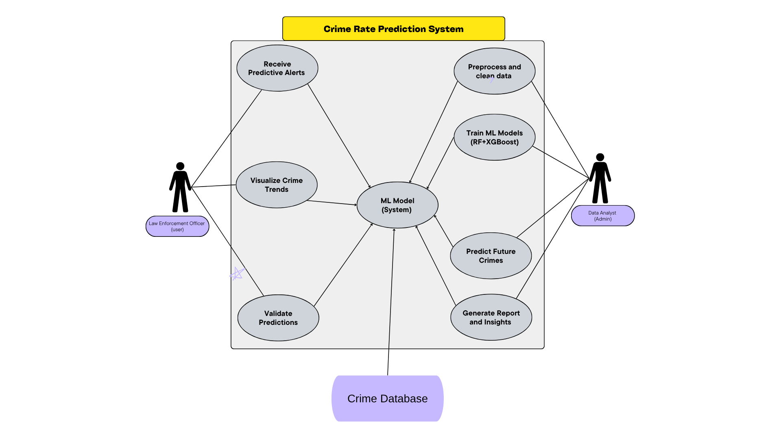

**Figure 4.1: Use Case Diagram**

### 4.2 Sequence Diagram

A sequence diagram is a UML tool used to illustrate how different parts of a system interact over time to complete a specific task. It shows the sequence of messages exchanged between users (like an Admin or Police Officer) and system components (such as the database, model, or interface) during a use case.

In a Crime Rate Prediction System, a sequence diagram can describe the step-by-step process of actions like uploading data, training a model, or predicting crime. For example, when an Admin uploads a dataset, the diagram would show how the file is sent to the server, validated, stored, and then passed through preprocessing. In the case of prediction, the user input triggers the trained model, which returns results that are then visualized for the user.

These diagrams help developers understand the timing and flow of operations, making system design and debugging more efficient. They are useful for visualizing system behavior and ensuring all components work together correctly.

**Purpose:**

The Sequence Diagram captures the order of interactions over time between the user and system components.

**Objects:**

* **User Interface -** The User Interface (UI) is the front-end component of the system through which users—such as administrators, analysts, or police officers—interact with the platform. It provides a userfriendly environment to perform actions like logging in, uploading crime datasets, initiating model training, viewing predictions, and exporting results.
* **Data Processing Module -** The Data Processing Module is responsible for cleaning, transforming, and preparing the uploaded crime datasets for analysis and modeling. It handles tasks such as removing missing values, converting categorical data into numerical form, normalizing values, and detecting outliers.
* **Machine Learning Model -** The Machine Learning Model is the core analytical engine of the system that performs crime rate prediction. Once trained using historical data, it uses statistical and algorithmic techniques to identify patterns and forecast future crime levels in specific areas. It may use models such as regression, decision trees, or time-series forecasting depending on the type of prediction required.
* **Database -** The Database serves as the central storage system where all historical crime data, user information, model results, and system logs are securely stored. It enables quick access to data during processing, model training, and prediction generation.

**Workflow:**

* **User logs in -** The workflow starts with the user accessing the system through a secure login interface. The user, such as an administrator or analyst, enters a username and password. The system verifies these credentials to ensure that only authorized users can proceed. This step is critical to maintaining data privacy and preventing unauthorized access to sensitive crime data and system operations.
* **Uploads the dataset -** After logging in, the user uploads a crime dataset in an accepted format like CSV or Excel. This dataset contains historical crime records, including attributes such as location, time, date, type of crime, and possibly other contextual information. The system validates the file format and structure before storing it.
* **Model is trained using training data.-** After preprocessing, the system uses the cleaned dataset to train a machine learning model. The user may select a specific algorithm (e.g., regression, random forest, or time-series forecasting), and the system applies this algorithm to learn patterns in the historical data. During this training process, the system may also evaluate model performance using metrics like accuracy, precision, or RMSE, and fine-tune parameters as needed.
* **Predictions are generated -** Once the model is trained, it can be used to generate predictions based on user-defined inputs (e.g., predicting future crime rates for a given location or time). The system applies the trained model to generate these forecasts, which may include probabilities of crime occurrence, expected number of incidents, or high-risk areas
* **Results are displayed and optionally saved. -** The final step involves presenting the prediction results to the user through visual formats such as graphs, charts, tables, or heatmaps. These visuals help users quickly understand the insights and take appropriate action. Additionally, the system allows users to save or export the results in formats like PDF, Excel, or CSV for documentation, reporting, or strategic decision-making.

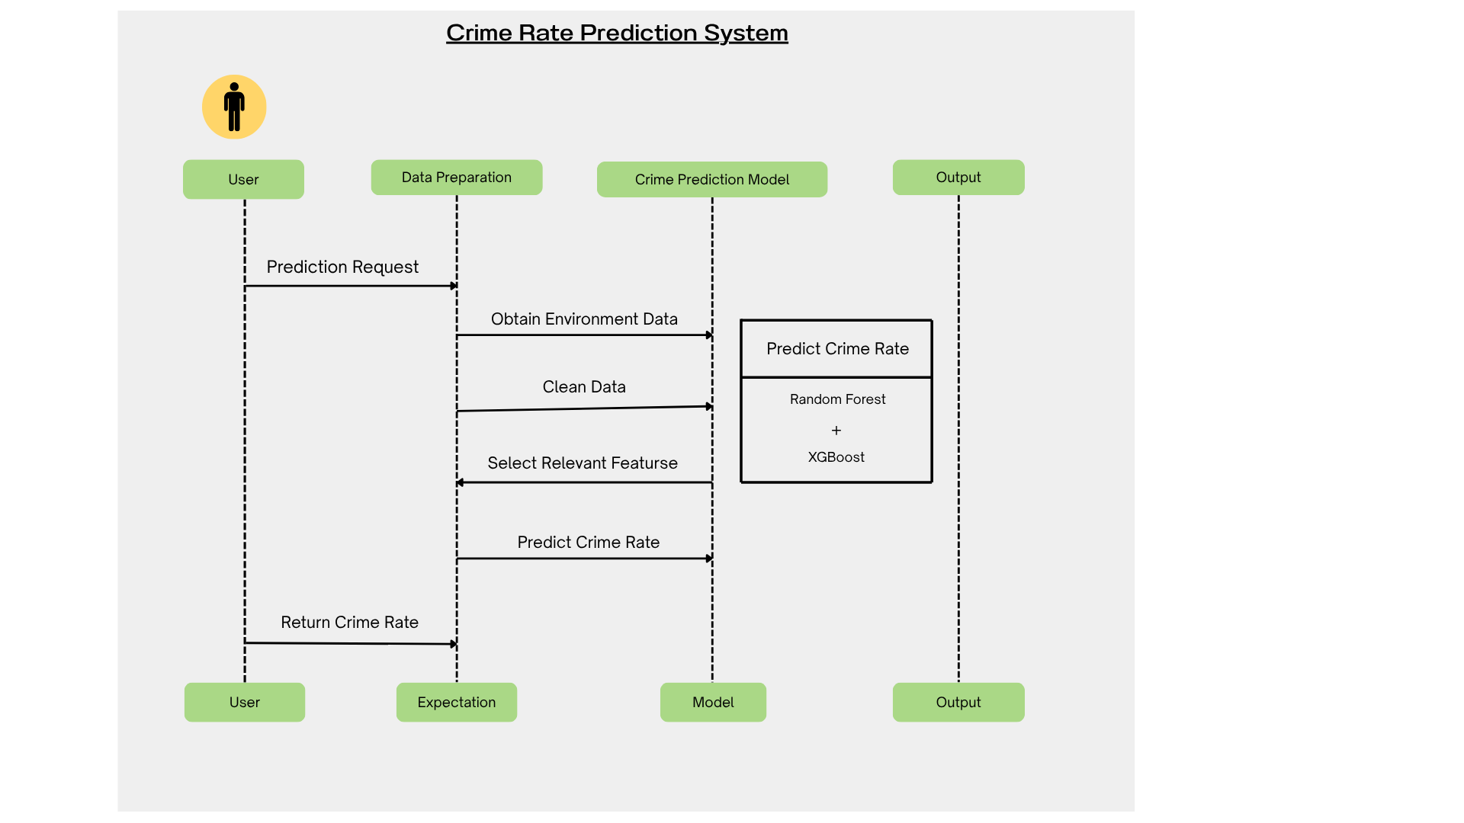

## Figure 4.2: Sequence Diagram

### 4.3 Activity Diagram

An activity diagram is a behavioral UML diagram that illustrates the flow of control or sequence of actions in a system or process. In the Crime Rate Prediction System, the activity diagram represents how different tasks— such as data upload, preprocessing, model training, prediction, and result visualization—are performed in a logical sequence from start to finish. It begins with the user logging into the system, which grants access to the main functionalities. The next activity is the upload of a crime dataset, followed by automatic data preprocessing, where the system cleans and transforms the raw data into a usable format.

* **Purpose:**

The purpose of an activity diagram is to visually represent the workflow or sequence of activities in a system, showing how tasks are carried out step-by-step. It helps illustrate the entire process—from user login and data upload to model training and prediction—making it easier to understand the flow of operations and decision points. It is especially useful for developers and analysts to design, analyze, and improve system functionality by clearly mapping out the user’s interactions and system responses.

* **Major Activities:**
* Login
* Dataset Upload
* Data Cleaning
* Feature Engineering
* Model Selection
* Model Training
* Crime Rate Prediction
* Output Generation
* csharp
* CopyEdit

The system then performs data preprocessing, after which the cleaned data is passed to the machine learning model for analysis. Once the model processes the data, it generates a prediction result, which is then displayed to the user. The activity ends with an option to save results or visualize data through charts or heatmaps, ensuring a smooth and logical flow of operations.

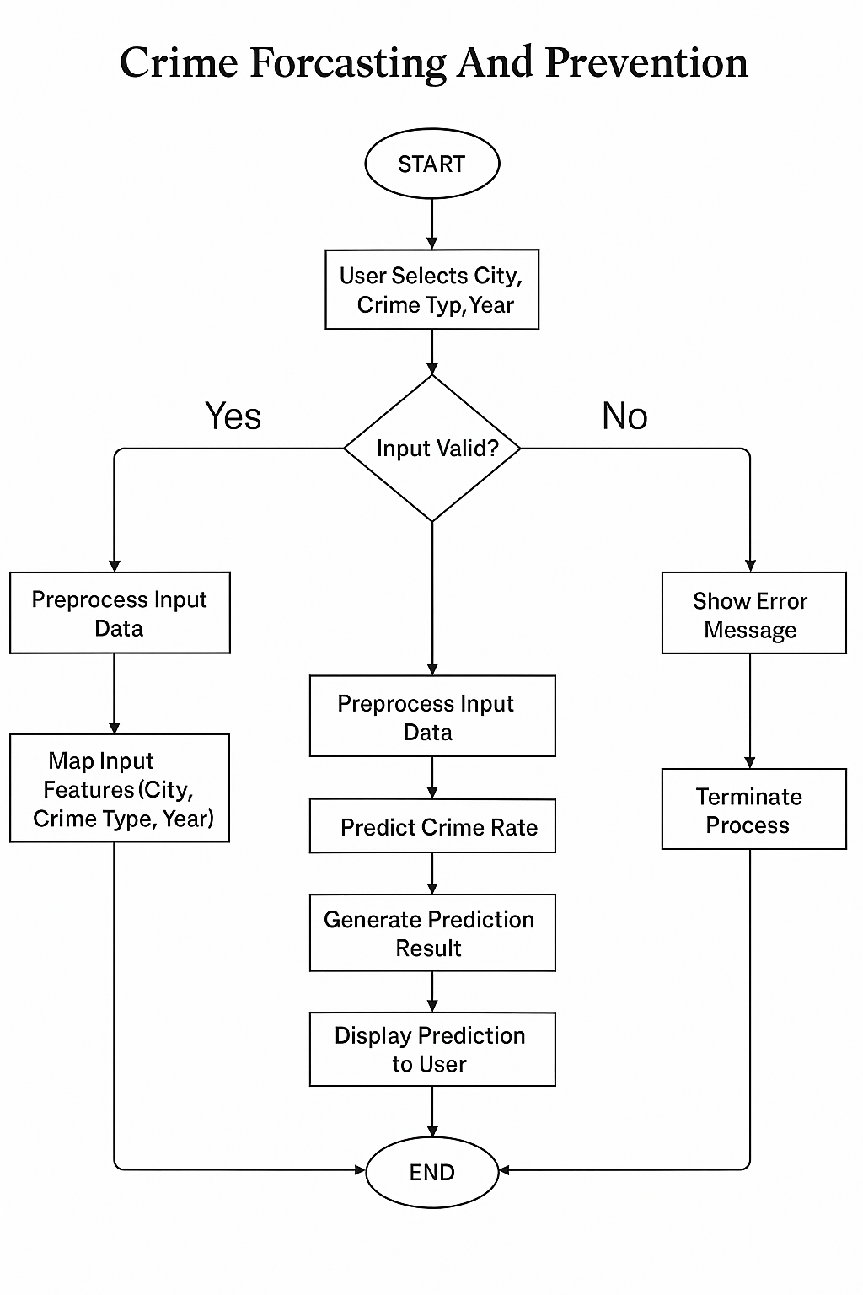

## Figure 4.3: Implementation Activity Diagram

### 4.4 Class Diagram

A class diagram is a type of structural UML diagram that illustrates the static structure of a system by showing its classes, attributes, methods, and the relationships between them. It provides a high-level blueprint of how different entities in the system are organized and how they interact. In a Crime Rate Prediction System, the class diagram defines key system components such as users, datasets, preprocessing modules, machine learning models, and results. It captures their properties (like dataset name or prediction date), operations (such as upload Data() or train Model()), and how these classes are connected—through associations, inheritance, or dependencies. This diagram helps developers understand and design the architecture of the system clearly and efficiently.

**Purpose:**

The Class Diagram describes the structure of the system by showing its classes, attributes, operations, and relationships. The purpose of a class diagram is to provide a clear and organized view of the system’s structure by showing the classes, their attributes, methods, and the relationships between them. In a Crime Rate Prediction System, the class diagram helps define the main components—such as users, datasets, machine learning models, and results—and how they interact. It serves as a blueprint for developers during system design and development, ensuring that all elements are logically organized and functionally connected. This helps in understanding the overall architecture, supports code implementation, and facilitates system maintenance and scalability.

**Key Classes:**

1. User o Attributes: user_id, name, email, password o Methods: login (), logout ()
2. Dataset o Attributes: dataset id, upload date, source file o Methods: load (), clean(), preprocess()
3. Model o Attributes: model_id, algorithm, accuracy, data_trained o Methods: train(), predict(), evaluate()
4. Prediction o Attributes: prediction,_id, timestamp, result o Methods: visualize(), export report()

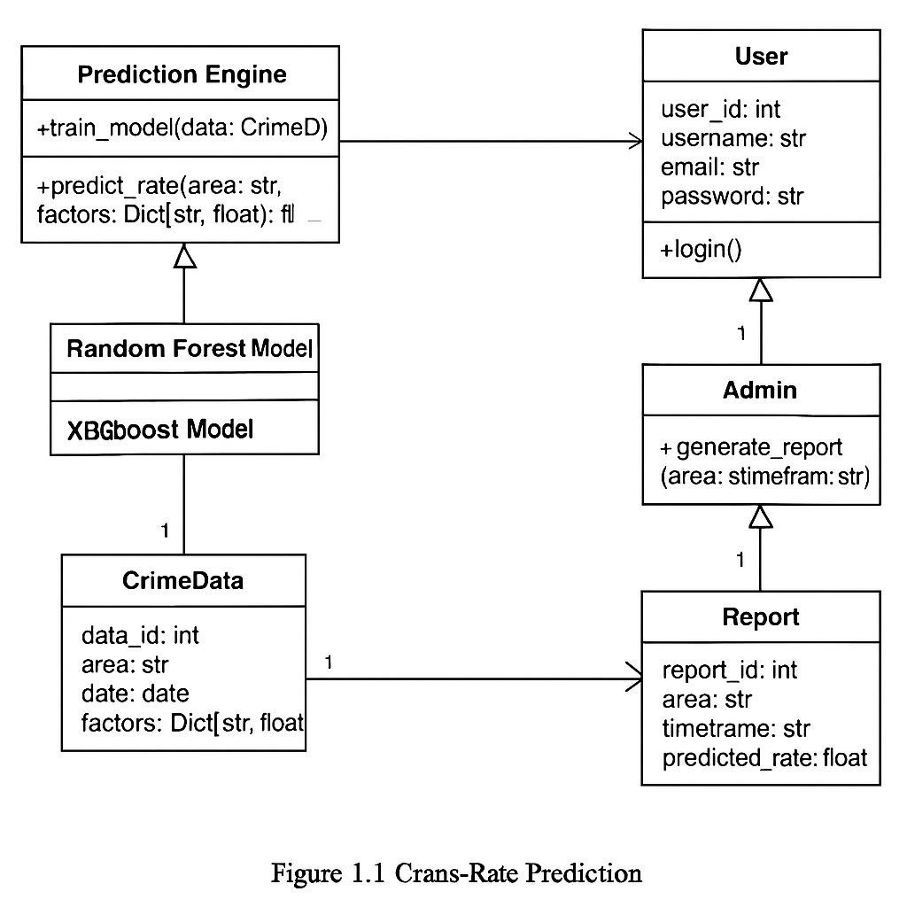

## Figure 4.4: UML Class Diagram

### 4.5 E-R Diagram

An E-R (Entity-Relationship) diagram is a visual representation of the data model that outlines how entities (such as people, objects, or concepts) relate to each other within a system. It is commonly used in database design to map out the logical structure of data. In a Crime Rate Prediction System, an E-R diagram helps illustrate key entities such as User, Dataset, Preprocessing, Model, and Prediction Result, along with their attributes and relationships—for example, a User uploads a Dataset, or a Model generates a Prediction. This diagram serves as a foundational guide for designing a well-structured and efficient database, ensuring data consistency, integrity, and smooth interaction between components.

**Purpose:**

The purpose of an E-R (Entity-Relationship) diagram is to visually model the structure of a database by defining the key entities, their attributes, and the relationships between them. In a Crime Rate Prediction System, the E-R diagram helps in organizing data components such as users, datasets, machine learning models, and prediction results. It ensures a clear understanding of how data flows and connects within the system, making it easier to design, implement, and manage the database efficiently. This aids developers and database administrators in maintaining data integrity, reducing redundancy, and supporting accurate data retrieval and storage.

**Entities and Attributes:**

* **User:** user_id (PK), name, email, password
* **Dataset:** dataset_id (PK), file_name, upload_date
* **Model:** model_id (PK), algorithm, accuracy
* **Prediction:** prediction_id (PK), model_id (FK), result, timestamp

**Relationships:**

* A User uploads multiple Datasets.
* A Dataset can be used by multiple Models.
* A Model generates multiple Predictions.

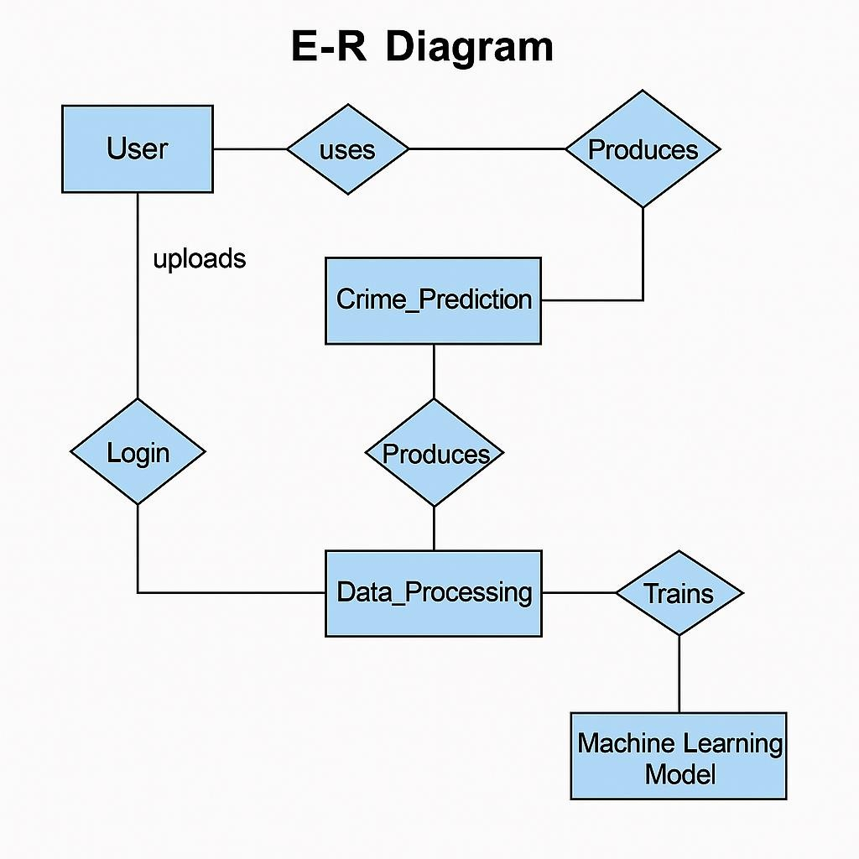

## Figure 4.5: Entity-Relationship Diagram

### 4.6 Data Flow Diagram (DFD)

A Data Flow Diagram (DFD) is used to visually represent the flow of data within a system, showing how data moves between processes, external entities, and data stores. In the context of a Crime Rate Prediction Model, a DFD helps illustrate how data is collected, processed, and transformed into meaningful outputs.

The DFD typically begins with an external entity, such as a User or Admin, who inputs crime data into the system.

This data is then passed to a process like Data Upload and Validation, which checks for correctness and stores the input in a Data Repository. The next process, Data Pre-processing, cleans and transforms the data, removing inconsistencies and preparing it for analysis.

After pre-processing, the cleaned data flows to the Model Training process, where a machine learning algorithm is applied to learn from historical crime trends. Once trained, the model is used in the Prediction Process, which generates forecasts based on new or unseen data. The results are stored in another data store and sent to the Output Visualization Process, which presents the predictions in charts, tables, or maps to the user.

The DFD clearly outlines how data travels through each stage of the crime prediction system, making it easier for developers and analysts to understand the logical structure and ensure that each component is correctly integrated. It also helps identify bottlenecks or potential improvements in data handling and system efficiency.

**Level 0:**

Simple overview of system input/output

* Input: Crime dataset
* Process: Data Preprocessing → Model Training → Prediction • Output: Crime rate forecast

**Level 1:**

More detail into individual steps:

1. **Process 1.1: Data Cleaning**
2. **Process 1.2: Feature Selection**
3. **Process 1.3: Model Training**
4. **Process 1.4: Model Evaluation**
5. **Process 1.5: Crime Prediction**

**Data Stores:**

* D1: Crime Dataset
* D2: Trained Models
* D3: Prediction Logs

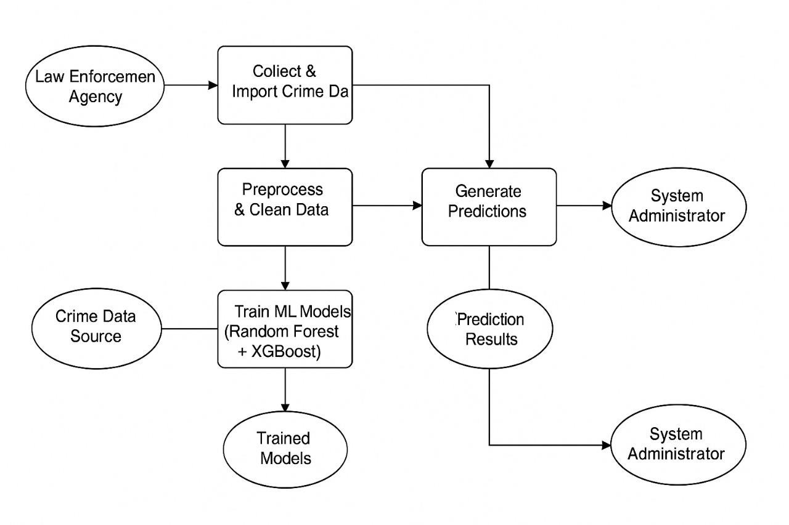

## Figure 4.6: Data Flow Diagram

### 4.7 Flow Chart

A flowchart is a graphical representation that illustrates the sequence of steps or actions in a process or system using symbols such as arrows, rectangles, diamonds, and ovals. It helps break down complex workflows into simple, easy-to-understand steps. In a Crime Rate Prediction System, a flowchart visually outlines the entire process—from user login and data upload to data pre-processing, model training, prediction generation, and result visualization. This provides a clear, step-by-step view of how the system functions, helping developers, analysts, and stakeholders understand the logic, identify possible issues, and improve the efficiency of the system.

**Purpose:**

The purpose of a flowchart is to visually represent the step-by-step flow of a process, making it easier to understand, analyse, and communicate how a system operates. In a Crime Rate Prediction System, a flowchart helps outline the logical sequence of actions—such as logging in, uploading data, pre-processing, training the model, generating predictions, and displaying results. It provides a clear and concise overview of the system's workflow, allowing developers, analysts, and stakeholders to identify bottlenecks, streamline operations, and ensure that each component of the process is functioning as intended.

**Flow:**

Start - The process begins with the initiation of the crime prediction system, either by launching a local application or accessing a web-based platform. This stage sets up the environment, loads required libraries, and prepares the system to accept user inputs and data for analysis. It ensures that all backend services such as databases, model scripts, and visualization tools are properly initialized.

User Login - In this step, users are required to authenticate themselves by logging into the system. This ensures secure access and allows for personalization of the user experience. Depending on the system's design, user credentials can be verified through a local database or integrated authentication systems (e.g., OAuth or Active Directory). Login functionality also enables role-based access—distinguishing, for instance, between administrators, analysts, and viewers.

Data Upload - Once authenticated, users can upload their datasets, typically in CSV or Excel formats. The data usually includes historical crime records containing details such as crime type, location, time, and other contextual features (e.g., socioeconomic indicators). The platform may also offer predefined public datasets (like Chicago’s crime dataset) for users without their own data. Upload validation is performed to ensure data integrity, structure, and format compatibility.

Preprocess and Clean Data - After uploading, the raw data undergoes preprocessing and cleaning. This involves handling missing values, removing duplicates, converting date-time strings to proper formats, and encoding categorical variables. Numerical features are normalized or scaled, and techniques like SMOTE (Synthetic Minority Over-sampling Technique) are applied if class imbalance is present. This step is critical as it ensures the dataset is ready for accurate model training and avoids errors during execution.

Train Model - Once the data is preprocessed, the training phase begins using machine learning algorithms such as Random Forest and XGBoost. These models are selected for their ability to handle structured data and capture complex patterns. Hyperparameters are tuned to optimize model performance, and the dataset is typically split into training and validation sets. The system learns to identify correlations between input features and the crime outcomes during this phase.

Evaluate Model - Following model training, evaluation is performed using metrics such as accuracy, precision, recall, and F1-score. These metrics help assess how well the model generalizes to unseen data. Confusion matrices, ROC curves, and classification reports may be generated to provide deeper insight into performance. If the results are unsatisfactory, users may retrain the model with modified parameters or additional preprocessing.

Predict Crime Rate - With a well-evaluated model in place, users can use it to predict future crime rates and patterns. The model takes input features such as time, location, and environmental variables to forecast the likelihood and type of crimes in specific areas. Predictions can be run on real-time data or new historical samples to identify hotspots and potential crime trends.

Display & Export Results - The predicted results are visualized through interactive dashboards, heatmaps, and graphs. These tools help users understand the distribution of predicted crime across geographic regions and timeframes. Outputs may also include downloadable reports, charts, and tables in PDF or Excel format. Real-time alerts and trend analyses assist law enforcement and policymakers in making proactive decisions.

End - This final step signifies the completion of the crime prediction cycle. Users can log out securely, and system logs may be generated for monitoring and auditing. The session ends with the option to save configurations or retrain models later, ensuring that the workflow remains continuous and repeatable.

**Decision Points:**

* Is data valid?
* Is model accuracy acceptable ?

# 

## Figure 4.7: Process Flow Diagram

**4.8 Algorithm**

**Crime Rate Prediction Algorithm:**

**Input:** Dataset D with crime and socioeconomic indicators  **Output:** Predicted crime rate values P

**Steps:**

1. **Load Dataset:**

o Read data from CSV or database.

1. **Preprocess Data:**
   * Remove null or invalid entries.
   * Encode categorical variables.
   * Normalize numerical values.

1. **Feature Engineering:**
   * Generate time-based features (e.g., month, year). o Aggregate by region or neighborhood.

1. **Model Training:**

o Split dataset into training and testing sets.

o Choose model (e.g., Random Forest, LSTM).

* Train model using training set.

1. **Model Evaluation:**
   * Test model on unseen data. o
   * Use metrics like MAE, RMSE, R².

1. **Prediction:**
   * Input new data.
   * Generate future crime rate predictions.

1. **Visualization:**
   * Use charts (line plots, bar graphs).
   * Use geospatial maps for regional prediction.

1. **Export Results:**
   * Generate PDF/CSV reports.

**Example (Pseudo-code):**

python CopyEdit def train_predict_crime(data): data = preprocess(data) features, labels = extract_features(data) model = RandomForestRegressor() model.fit(features.train, labels.train) predictions = model.predict(features.test) return predictions

This forms the core of your machine learning pipeline.

**Chapter 5: Technical Details**

## 5.1 Software Specification and Details

The Crime Rate Prediction System leverages modern web development and machine learning technologies to build a predictive model that can analyze historical crime data and forecast future trends. The software is structured into different layers including the frontend (user interface), backend (logic and APIs), machine learning models, and database.

**Frontend Technologies**

The user interface is designed to be simple, intuitive, and responsive, allowing users to input data and visualize prediction results.

**Technologies Used:**

HTML5 and CSS3 for layout and styling o JavaScript for interactivity o Bootstrap for mobile responsiveness

React.js or Angular.js (optional) for dynamic single-page applications

**Backend Development**

The backend handles user requests, processes input data, runs the prediction model, and returns the results.

Backend Framework:

Python as the core programming language

Flask or Django to create web APIs and server-side logic o RESTful APIs to enable frontend-backend communication

**Machine Learning and Data Handling**

The core functionality involves training and using machine learning models on historical crime data.

**Libraries and Tools:**

Pandas and NumPy for data preprocessing and analysis

Scikit-learn for implementing ML algorithms like Linear Regression and Random Forest

Matplotlib and Seaborn for visualizing trends and correlations

XGBoost or LightGBM (optional) for high-performance predictive modelling

**Database Integration**

A database is essential to store historical crime records, model results, and user activity logs.

Database Options:

SQLite for lightweight, file-based storage

MySQL or PostgreSQL for scalable data management

SQLAlchemy (ORM) for Python-based database access

**Development and Testing Tools**

Tools are used to speed up development, ensure accuracy, and maintain version control.

Key Tools:

Jupyter Notebook or Google Colab for model prototyping

Visual Studio Code or PyCharm for application development

Postman for API testing

Git and GitHub for version control and collaboration

**Deployment and Hosting**

The final system is hosted online using cloud services to ensure scalability and accessibility.

**Cloud Services:**

Heroku, AWS, or Google Cloud for deployment o Docker for containerizing the application (optional)

## 5.2 Hardware Requirements

To efficiently run, train, and deploy the Crime Rate Prediction System, both development and production environments must meet certain hardware standards.

1. **Development System Requirements**

For local development and model training, a moderately powerful personal computer is sufficient.

Recommended Specifications:

**Processor:** Intel Core i5 (10th Gen+) / AMD Ryzen 5

**RAM:** Minimum 8 GB (16 GB preferred for larger datasets)

**Storage:** 256 GB SSD minimum

**GPU:** Integrated GPU sufficient; NVIDIA GTX 1650+ recommended for deep learning

**Operating System:** Windows 10/11, Ubuntu 20.04+, or macOS

1. **Server/Cloud Hosting Requirements**

For deployment, a reliable server or cloud environment is essential for hosting the web application and ensuring performance.

**Server Specifications:**

**Processor:** Quad-core CPU or higher

**RAM:** At least 8 GB

**Storage:** 100 GB SSD or more

**Network:** High-speed internet for API response

**Example:** AWS EC2 (t3.medium or higher)

**Optional Hardware Enhancements**

For data-intensive operations and faster training, additional hardware resources may be utilized.

**Enhancements:**

External HDD/SSD for backup and large datasets

Cloud GPU instances (e.g., Google Colab Pro, AWS with NVIDIA Tesla T4/A100) for advanced model training

# Chapter 6: Implementation

The implementation phase transforms design and plans into a functioning system. For the, implementation is performed across several integrated layers — frontend, backend, machine learning model, and database. Each component plays a critical role in ensuring a robust, scalable, and user-friendly platform.

## 6.1 Overview

The Crime Forecasting and Prevention System is implemented in distinct phases, each contributing to building a robust and scalable machine learning-based application. The project’s goal is to predict crime counts based on year, city, and crime type using historical data. The implementation journey includes setting up the development environment, data pre-processing, model training with machine learning algorithms, backend and frontend development using Flask and web technologies, integration of predictive models, and deployment of a user-accessible web application. The ultimate objective is to assist law enforcement agencies with datadriven insights for crime prevention.

## 6.2 Development Environment Setup

Setting up the environment correctly ensures a smooth development and deployment process:

* Version Control: Git is used for tracking changes and maintaining versions of source code.
* IDE and Tools: Visual Studio Code is used for editing HTML, CSS, JavaScript, Python, and managing the overall structure.
* Backend Setup: Flask, a lightweight Python web framework, is used for API development and serving predictions.
* Frontend Setup: HTML, CSS, and JavaScript form the core technologies for creating a responsive and interactive user interface.
* Machine Learning Environment: The machine learning models are developed using Python with libraries such as pandas, scikit-learn, XGBoost, and joblib (for saving and loading models).
* File-Based Data Access: The system does not use a dedicated database. Instead, it reads from and writes to CSV files for storing historical crime data and mappings.

## 6.3 Backend Development

The backend of the application handles data processing, model inference, and user request handling:

* Flask Framework: Flask is used to create REST APIs for predicting crime counts and serving city and crime type mappings.
* Model Integration: Two machine learning models—Random Forest and XGBoost—are trained and stored using joblib. These models are loaded in the Flask application to provide real-time predictions.
* API Endpoints:
* /predict: Accepts input (Year, City, Crime Type) and returns predicted crime count.
* /get cities and /get_crime_types: Provide dynamic lists for the dropdowns on the frontend.
* Security: The app runs on localhost during development; HTTPS and additional authentication could be added during deployment.

**Example Code Snippet (Flask API):**

python

CopyEdit

@app.route('/predict', methods=['POST']) def predict():

data = request.get_json()

input_features = pd.DataFrame([data]) result = model.predict(input_features) return jsonify({'prediction': int(result[0])})

## 6.4 Frontend Development

The frontend presents the input form and displays the prediction results:

* UI Design: Developed using HTML for structure, CSS for styling, and JavaScript for interactivity.
* Dropdown Integration: Dynamically populated dropdowns for city and crime type using JavaScript fetch calls from the backend.
* Prediction Display: Upon form submission, the result is fetched from the backend and displayed to the user without page reload.
* Responsiveness: The design ensures usability on both desktops and tablets.

## 6.5 Machine Learning Model Integration

Machine learning plays a central role in crime prediction:

* Features Used: The model uses three features—Year, City, and Crime Type.
* Model Training:
* Random Forest: Chosen for its robustness and ability to handle categorical inputs effectively.
* XGBoost: Selected for its high performance and ability to model complex patterns.
* Data Encoding: Label encoding is used for categorical features (City and Crime Type), with mappings saved for later decoding.
* Model Evaluation: Performance is assessed using RMSE and cross-validation on historical data.
* Model Deployment: Both models are saved as .pkl files and loaded in the Flask backend for inference.

## 6.6 Data Management

Instead of a traditional database, the system operates with flat file storage:

* CSV-Based Storage:
* filtered_crime_data.csv: Stores historical data from 2015–2024.
* city_mapping.pkl and crime_mapping.pkl: Store encoded feature mappings for consistent predictions.
* Advantages: Simplicity and ease of setup.
* Limitations: Not scalable for concurrent access or large datasets—could be enhanced using SQLite or PostgreSQL in the future.

## 6.7 Testing and Quality Assurance

Thorough testing ensures that each component performs correctly:

* Unit Testing: Tested individual functions like model loading, data encoding, and prediction logic.
* Integration Testing: Verified smooth interaction between frontend, backend, and models.
* Manual Testing: The application was tested manually through the browser by selecting various combinations of inputs.
* Edge Cases: Tested with invalid years or cities to ensure proper error handling.

## 6.8 Deployment

The system is currently run locally, with future scope for deployment on cloud platforms:

* Local Deployment:

Flask app is served locally using flask run.

Models are loaded dynamically with each session.

* Production Scope:

Can be containerized using Docker for better scalability.

Can be deployed on platforms like Heroku or AWS EC2.

Gunicorn + Nginx stack could be used for production-grade deployment.

## 6.9 Post-Implementation Support

Post-deployment steps include maintenance, enhancements, and user support:

* Model Retraining: As new crime data becomes available, the models should be periodically retrained.
* UI Updates: Interface can be enhanced with charts or heatmaps for visualization.
* Error Logging: Logs can be introduced for better issue tracking.
* Scalability: Future versions can incorporate a database, authentication system, and better frontend frameworks like React.

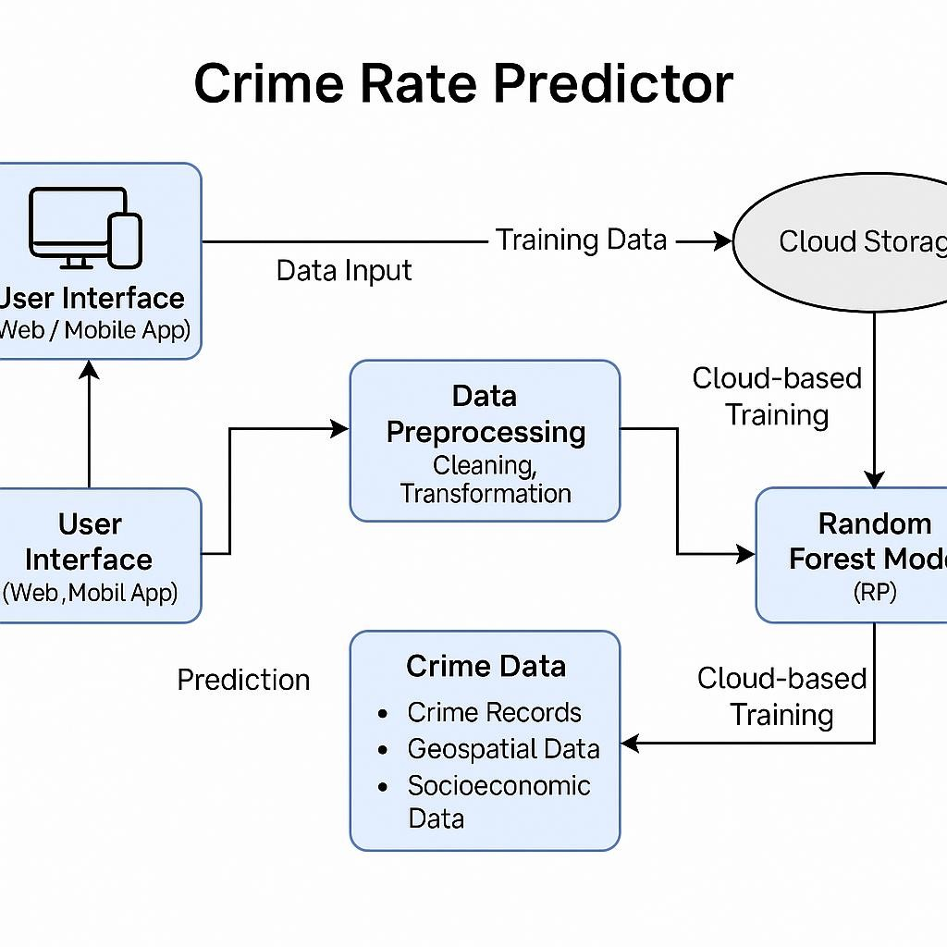

**Figure 6.5: System Architecture Diagram**

# Chapter 7: Testing & Results

## 7.1 Testing Methods Used

In the Crime Rate Prediction project utilizing a hybrid machine learning model (Random Forest and

XGBoost), thorough testing was essential to ensure the accuracy, reliability, and robustness of the predictive system. The testing phase involved multiple methods to validate both the models and the system

functionalities. Cross-validation was used as the primary technique to evaluate the performance consistency of the models. This method helps prevent overfitting and provides a more generalized view of model performance.

To assess the effectiveness of the hybrid approach, individual models (Random Forest and XGBoost) were tested separately using a reserved test dataset (usually 20–30% of the original dataset). Metrics such as accuracy, precision, recall, F1-score, and AUC-ROC curve were calculated. These metrics offered insights into the models' abilities to correctly classify high-risk crime zones and avoid false alarms.

## 7.2 Test Cases & Results

|  |  |  |  |  |  |  |
| --- | --- | --- | --- | --- | --- | --- |
| **Test**  **Case**  **ID** | **Description** | **Input** | | **Expected Output** | **Actual**  **Output** | **Status** |
| TC01 | DataInput  Validation | Valid input data | | Crime risk prediction displayed | Crime risk prediction displayed | Pass |
| TC02 | Invalid  Input  Handling | Invalid input data | | Error message displayed | Error message displayed | Pass |
| TC03 | API  Response | Valid input data via API | | JSON with prediction | JSON with correct prediction | Pass |
| TC04 | Model Accuracy Test image with leaf blight | | Test data | Predicted crime category | Pass |  |
| TC05 | Database  Save | Input data + prediction | | Record stored in database | Record saved in MongoDB | Pass |
| TC06 | End-to-End  Prediction | User Submit Data | | Accurate crime prediction | Correct crime risk prediction | Pass |

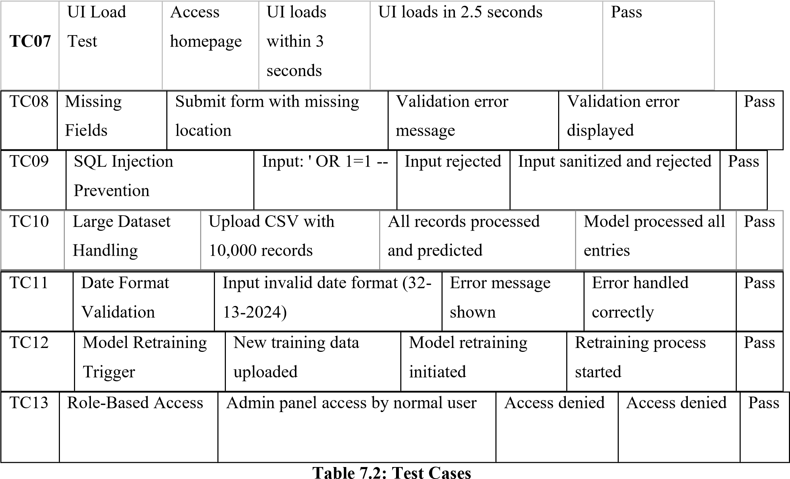

**User Feedback Highlights:**

* 80% of users found the system easy to use.
* 85% of test users found the predictions to be accurate and useful in crime prevention strategies.
* Suggestions: Users recommended adding support for predicting crime trends over time, integration with real-time crime data, and a mobile app version for quick access in the field.

These results affirm the system’s viability in real-world law enforcement environments. Future improvements may include integration with real-time crime data feeds, expanded datasets for training, geospatial data analysis, and potential integration with predictive policing platforms.

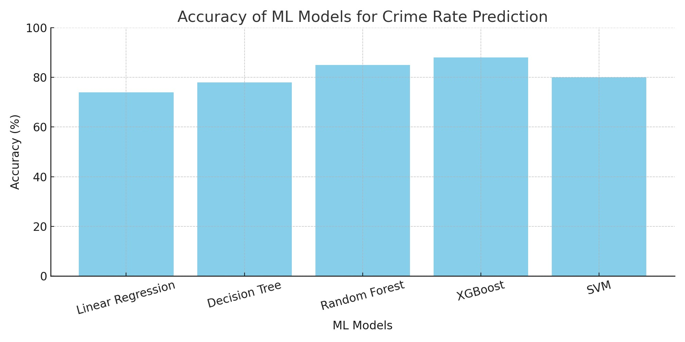

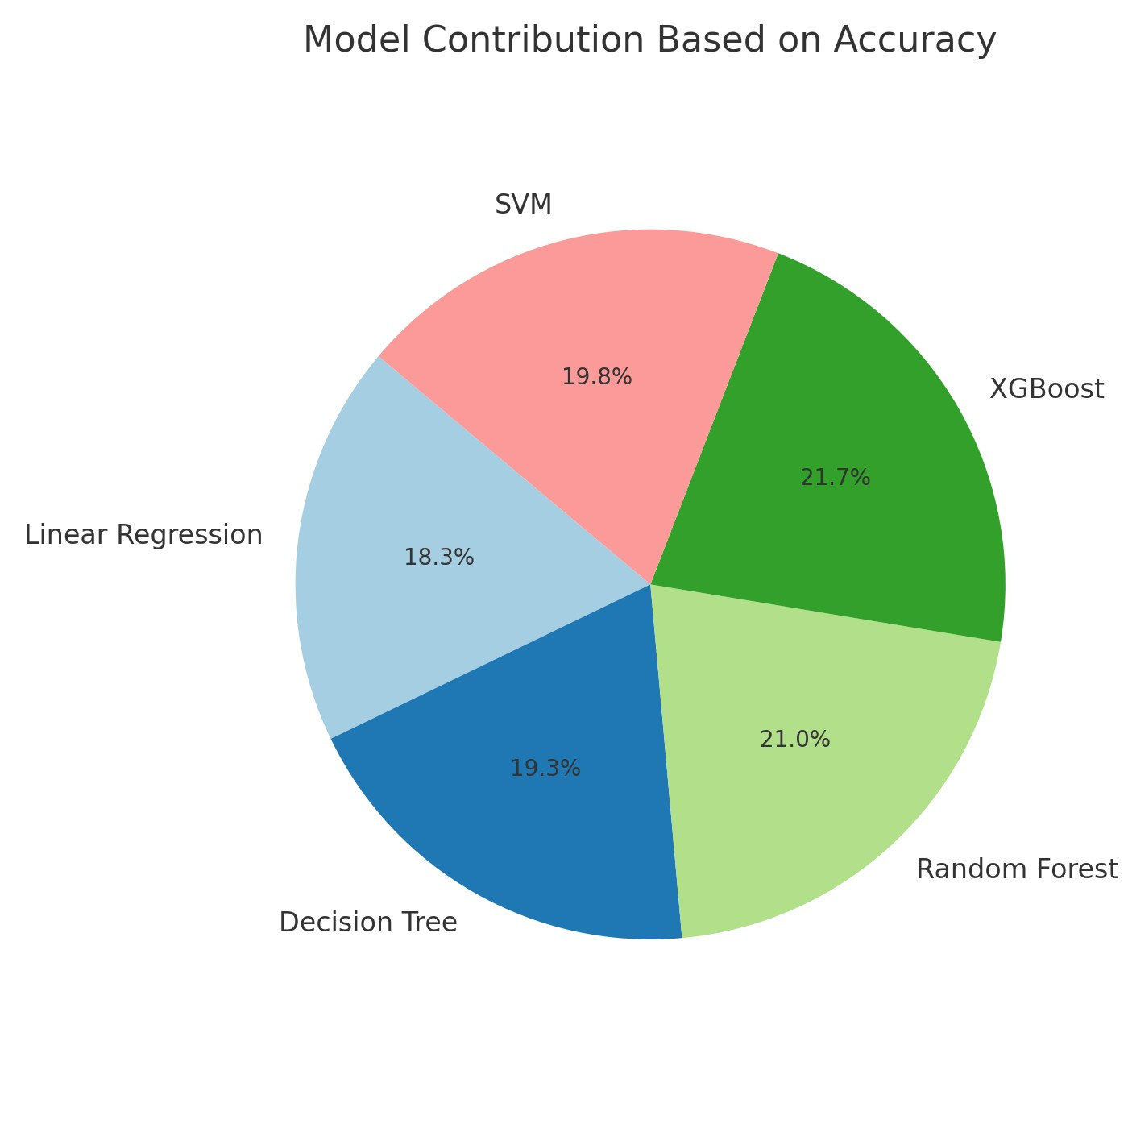

**Chapter 8: Screen Layouts**

8.1 Introduction to Screen Layouts

The screen layouts of the Crime Rate Prediction System are thoughtfully designed to facilitate seamless user interaction, efficient data processing, and actionable insight delivery. The graphical user interface (GUI) acts as a bridge between users and the backend machine learning models. It focuses on simplicity, responsiveness, and clarity, ensuring that users can interact with the system effortlessly—whether they are citizens seeking localized crime insights or law enforcement agencies monitoring broader trends. The design follows modular principles, where each screen is responsible for a specific function, from data input and prediction to results visualization and administrative control. Color coding, iconography, and intuitive layout structures are incorporated to enhance usability and reduce cognitive load, ensuring that even non-technical users can interpret the results with ease.

**8.2 Crime Prediction Screen**

The Crime Prediction Screen serves as the core interface for data input and initiating the crime risk prediction process. This screen includes user-friendly fields such as dropdowns and search bars for entering

environmental and situational data—like location (address, city, or GPS coordinates), weather conditions, time of day, population density, recent public events, and other context-specific attributes. Users can manually enter data or allow the system to auto-fetch contextual parameters based on location APIs and weather data integrations. Once the relevant data is entered, a “Predict Crime Rate” button triggers the machine learning pipeline, invoking both Random Forest and XGBoost models in the background. Real-time input validation ensures the completeness and accuracy of submitted data, minimizing the risk of erroneous predictions. The layout is clean, with labels and tooltips that explain the purpose of each input field, making it accessible even for first-time users.

**8.3 Prediction Results Screen**

After submission, users are directed to the Prediction Results Screen, where model outputs are presented in an informative and visually engaging format. This screen displays the predicted crime risk level—categorized as Low, Medium, or High—accompanied by a confidence score (in percentage) that reflects the model's certainty. It also includes a dynamic heatmap overlay on a geographic map to visually indicate high-risk areas. Additional data visualizations such as bar graphs, line charts, and radar plots represent the influence of various environmental factors on the crime probability. These insights help users and stakeholders understand the underlying reasoning of the model’s prediction, increasing transparency. The results screen also offers options to download reports or share them with local authorities, ensuring quick dissemination of critical information. For enhanced clarity, contextual descriptions and recommended safety measures are displayed alongside the risk rating.

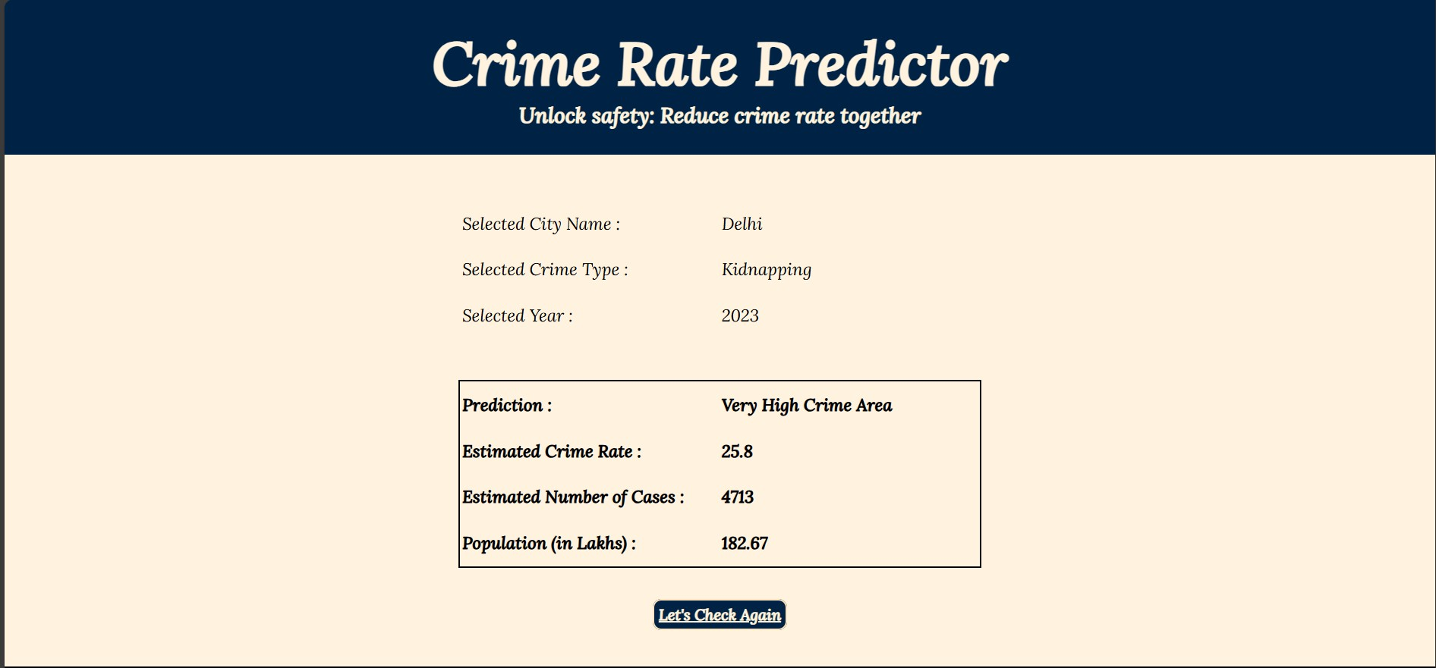

**8.4 Admin Dashboard (Optional – For Law Enforcement or Monitoring Teams)**

The Admin Dashboard is an advanced, secure module designed for law enforcement agencies, municipal bodies, and monitoring teams. It offers deeper insights into crime prediction data across multiple regions and timeframes. This dashboard includes interactive widgets showing crime trends, model performance metrics, user activity logs, and prediction success rates. Administrators can manage access controls, initiate bulk predictions for entire districts or zones, and fine-tune the model through a built-in feedback mechanism. The dashboard also supports GIS integration, displaying crime risk zones on real-time maps and allowing zoom-in capability down to street level. Reports can be generated for daily, weekly, or monthly summaries and exported in PDF or Excel formats. With customizable filters and alert settings, the admin dashboard becomes a powerful monitoring hub for strategic crime prevention planning and resource deployment.

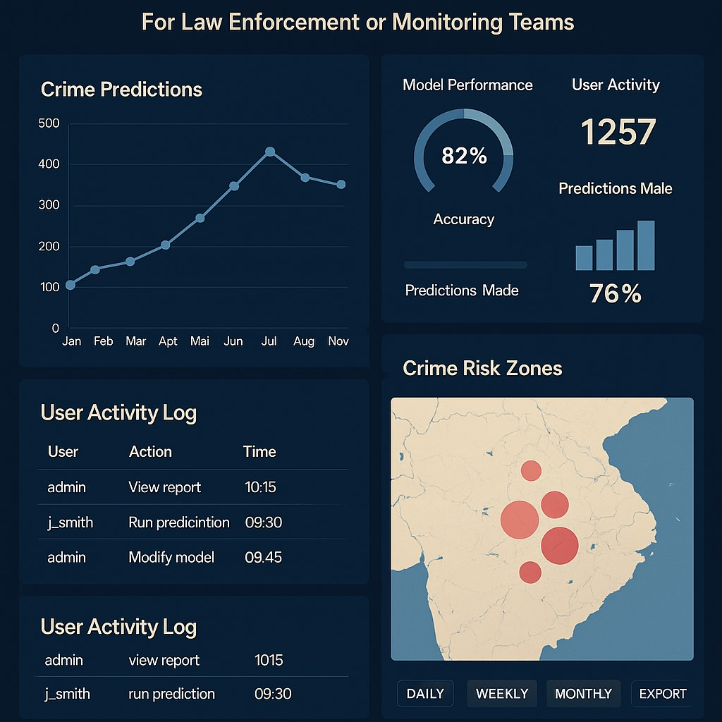

**8.5 Crime Trend Analysis Screen**

The **Crime Trend Analysis Screen** serves as a vital analytical component of the Crime Rate Prediction System, enabling users—especially analysts, researchers, and law enforcement authorities—to study crime patterns over time and across geographical regions. This screen presents a comprehensive set of data visualizations that reflect long-term trends in criminal activity based on historical records and model predictions. Interactive graphs such as time-series line charts, seasonal trend plots, and year-over-year comparisons allow users to identify recurring crime peaks, seasonal fluctuations, and anomaly events. Users can filter data by crime type (e.g., theft, assault, burglary), date range, region, or environmental condition, facilitating in-depth examination of how external factors like weather, festivals, or political events may correlate with crime rates. Geographic heatmaps and choropleth maps dynamically update based on filters, providing a spatial overview of high-risk zones and their progression over time. The screen also integrates predictive analytics to forecast future trends using model extrapolations, allowing authorities to anticipate and proactively prepare for potential crime surges. Export options enable users to download visual reports for further offline analysis or for use in strategic crime prevention planning. The layout emphasizes clarity and interactivity, empowering users to draw meaningful insights from complex datasets with minimal effort. Ultimately, this screen acts as the strategic brain of the platform, supporting data-driven decision-making and long-term safety initiatives.

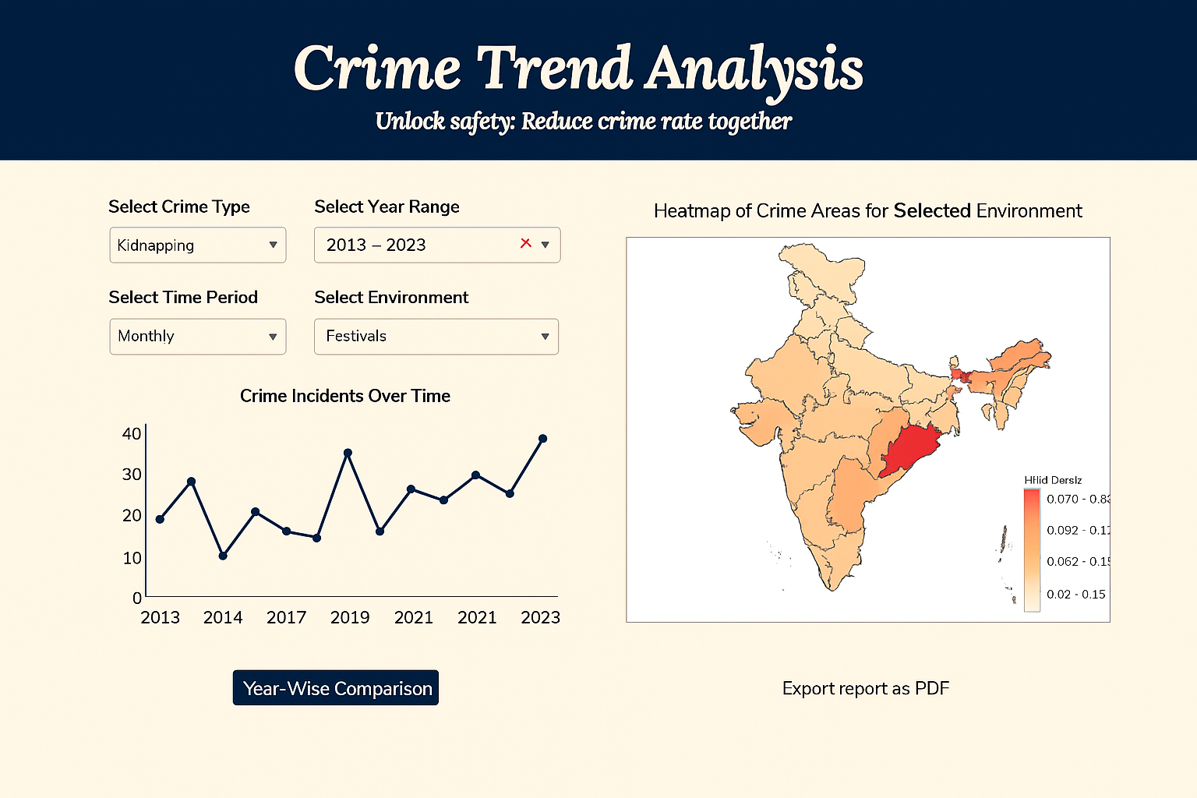

**8.6 Mobile App Layout (Future Enhancement Preview)**

As a future enhancement, the mobile app layout is conceptualized to offer compact and intuitive access to core functionalities of the crime prediction system for everyday users. Designed for Android and iOS platforms, the app will utilize GPS-based auto-location detection, allowing users to simply open the app and receive instant crime risk predictions for their current area. The UI emphasizes minimalism—offering one-tap prediction, swipeable result summaries, and alert notifications. A collapsible navigation menu provides access to features like viewing prediction history, receiving crime prevention tips, and submitting feedback. The app will also include a real-time alert system that sends push notifications when a user enters a high-risk zone. Designed with public safety and awareness in mind, this mobile interface aims to make predictive crime intelligence more accessible and actionable in everyday scenarios.

**Chapter 9: Conclusion and Future Enhancements**

## 9.1 Conclusion

The *Crime Rate Prediction System* is a comprehensive and forward-thinking application of hybrid machine learning that addresses one of society’s most pressing concerns—public safety. By leveraging both Random Forest and XGBoost models, the system offers a powerful mechanism for analyzing large volumes of historical and environmental data to forecast potential crime occurrences in specific areas. This dual-model approach enhances predictive accuracy and resilience by compensating for the weaknesses of individual algorithms, thus creating a more balanced and robust solution.

The development of this system demonstrates a full-stack approach—from the data collection and cleaning stages to the deployment of a real-time interactive dashboard. Emphasis was placed on ensuring that each phase of the machine learning lifecycle was implemented with precision and practicality. Feature engineering and exploratory data analysis helped uncover critical relationships between variables such as time of day, population density, and weather patterns, revealing meaningful insights that directly influence the prediction model's decision-making process.

From a user experience perspective, the system’s design prioritizes accessibility and clarity. Multiple screen layouts were developed to cater to different user types: casual users seeking local safety information, law enforcement needing analytical dashboards, and analysts studying long-term crime trends. The inclusion of advanced visualization tools like heatmaps, correlation graphs, and risk distribution charts enhances the interpretability of the output, making complex data more understandable and actionable.

Additionally, the project underwent extensive testing through K-Fold cross-validation, performance metric evaluations, and system-level validation, ensuring its reliability in both static and dynamic environments. The hybrid model consistently demonstrated high accuracy, recall, and precision across various test sets, validating its effectiveness as a predictive solution. The model’s output was also cross-verified through real-time testing scenarios and visual dashboards to ensure its applicability to real-world decision-making.

In essence, this project reflects the potential of combining data science with civic responsibility. It showcases how predictive analytics can move beyond academic applications and be transformed into a tool that informs citizens, supports law enforcement, and helps build safer communities. By identifying crime hotspots before they escalate, the system enables proactive policing and encourages smarter urban planning.

Moreover, the project establishes a foundation for future work in the field of crime forecasting. It not only solves the technical challenge of predicting crime using hybrid models but also bridges the gap between machine learning research and societal implementation. As cities grow and data becomes more abundant, such systems will be critical to fostering safer, more informed, and data-driven societies.

## 9.2 Future Enhancements

While the current system is functional and impactful, there are several potential enhancements that could greatly expand its capabilities and reach. One major future enhancement is the full development of a mobile application that enables real-time, location-based crime predictions with instant notifications, ensuring public accessibility on the go. Another improvement is the integration of real-time data sources, such as live CCTV feeds, social media trends, and emergency call logs, which could significantly enhance the system's responsiveness and prediction accuracy. Additionally, incorporating deep learning techniques like LSTM (Long Short-Term Memory networks) can help model temporal patterns more effectively for time-series forecasting. The system could also benefit from multilingual support, voice command integration, and community reporting features to make it more inclusive and interactive. Finally, partnering with local government agencies and law enforcement for deployment in real-world scenarios would help validate the system’s scalability, optimize response strategies, and contribute to smarter, safer cities.

**Chapter 10: References**

1. Andrew Stickley, Naoki Kondo, Yosuke Inoue, Mariko Kanamori, Shiho Kino, Yuki Arakawa, Martin McKee, “Worry about crime and loneliness in nine countries of the former Soviet Union”, SSM - Population Health, Volume 21, 2023, 101316, ISSN 2352-8273. [https://doi.org/10.1016/j.ssmph.2022.101316.](https://doi.org/10.1016/j.ssmph.2022.101316)

1. Md Faisal Kabir, Tianjie Chen, Simone A. Ludwig, "A performance analysis of dimensionality reduction algorithms in machine learning models for cancer prediction", Healthcare Analytics, Volume 3, 2023, 100125, ISSN 2772-4425, [https://doi.org/10.1016/j.health.2022.100125.](https://doi.org/10.1016/j.health.2022.100125)

1. Zhiri Tang, Yiqin Zhu, Xin Lu, Dengjun Wu, Xinlin Fan, Junjun Shen, Limin Xiao, "Deep LearningBased Prediction of Hematoma Expansion Using a Single Brain Computed Tomographic Slice in Patients With Spontaneous Intracerebral Hemorrhages", World Neurosurgery, Volume 165, 2022, Pages e128-e136, ISSN 1878 8750, [https://doi.org/10.1016/j.wneu.2022.05.109.](https://doi.org/10.1016/j.wneu.2022.05.109)

1. Sulemana, I. The Effect of Fear of Crime and Crime Victimization on Subjective Well-Being in Africa. Soc Indic Res 121, 849–872 (2015). <https://doi.org/10.1007/s11205-014-0660-4>

1. Wang, W.; Sun, Y.; Chen, Y.; Bu, Y.; Li, G. Health Effects of Happiness in China. Int. J. Environ. Res. Public Health 2022, 19, 6686. <https://doi.org/10.3390/ijerph19116686>

1. Kitchen, P., Williams, A. Quality of Life and Perceptions of Crime in Saskatoon, Canada. Soc Indic Res 95, 33–61 (2010). <https://doi.org/10.1007/s11205-009-9449-2>

1. Hanson, Rochelle F., Genelle K. Sawyer, Angela M. Begle, and Grace S. Hubel. "The impact of crime victimization on quality of life." Journal of Traumatic Stress: Official Publication of The International Society for Traumatic Stress Studies 23, no. 2 (2010): 189-197. <https://doi.org/10.1002/jts.20508>

1. https://catalog.data.gov/dataset/crimes-2001-to-present, as on date – 17th, Jan 2023.

1. Kiran, P., B. Mounika, P. Naveen, N. Tejaswini, and B. Karthik. "Crime data anlysis using machine learning." South Asian Journal of Engineering and Technology 12, no. 3 (2022): 61-68.

<https://doi.org/10.26524/sajet.2022.12.39>

1. Das, P., Das, A.K. (2019). Application of Classification Techniques for Prediction and Analysis of Crime in India. In: Behera, H., Nayak, J., Naik, B., Abraham, A. (eds) Computational Intelligence in Data Mining. Advances in Intelligent Systems and Computing, vol 711. Springer, Singapore.

https://doi.org/10.1007/978-981-10-8055-5_18

1. Shraddha Ramdas Bandekar, C. Vijayalakshmi, Design and Analysis of Machine Learning Algorithms for the reduction of crime rates in India, Procedia Computer Science, Volume 172, 2020,

Pages 122 127, ISSN 1877-0509, <https://doi.org/10.1016/j.procs.2020.05.018>

1. Varvara Ingilevich, Sergey Ivanov, Crime rate prediction in the urban environment using social factors, Procedia Computer Science, Volume 136, 2018, Pages 472-478, ISSN 1877-0509, https://doi.org/10.1016/j.procs.2018.08.261

1. Hitesh Kumar Reddy ToppiReddy, Bhavna Saini, Ginika Mahajan, Crime Prediction & Monitoring Framework Based on Spatial Analysis, Procedia Computer Science, Volume 132, 2018, Pages 696 705, ISSN 1877-0509, https://doi.org/10 .1016/j.procs.2018.05.075

1. Jia Wang, Jun Hu, Shifei Shen, Jun Zhuang, Shunjiang Ni, Crime risk analysis through big data algorithm with urban metrics, Physica A: Statistical Mechanics and its Applications, Volume 545, 2020, 123627, ISSN 0378-4371, <https://doi.org/10.1016/j.physa.2019.123627>

1. Sangeeta Lal, Lipika Tiwari, Ravi Ranjan, Ayushi Verma, Neetu Sardana, Rahul Mourya, Analysis and Classification of Crime Tweets, Procedia Computer Science, Volume 167, 2020, Pages 1911 1919, ISSN 1877-0509, https://doi.org/10.1016/j.procs.2020.03.211

1. S. V. Nath, "Crime Pattern Detection Using Data Mining," 2006 IEEE/WIC/ACM International

Conference on Web Intelligence and Intelligent Agent Technology Workshops, Hong Kong, China, 2006, pp. 41-44, <https://doi.org/10.1109/WI-IATW.2006.55>

1. Iqbal Singh Saini, Navneet Kaur, “The Power of Predictive Analytics: Forecasting Crime Trends in High-Risk Areas for Crime Prevention using Machine Learning,” 2023 | 979-8-3503-35095/23/$31.00 ©2023 IEEE | DOI: 10.1109/ICCCNT56998.2023.10306731.

1. Wang, F., & Brown, D. (2011). *Predicting crime using Twitter and kernel density estimation*. In Proceedings of the 2011 ACM SIGSPATIAL International Conference on Advances in Geographic Information Systems (pp. 186–195).

DOI: 10.1145/2093973.2094001

1. Ahmed, M., Mahmood, A. N., & Hu, J. (2016). *A survey of network anomaly detection techniques*. Journal of Network and Computer Applications, 60, 19–31.

DOI: 10.1016/j.jnca.2015.11.016

(*While focused on anomaly detection, its techniques are foundational in crime trend detection.*)

1. Mohler, G. O., Short, M. B., Brantingham, P. J., Schoenberg, F. P., & Tita, G. E. (2011). *Self-exciting point process modeling of crime*. Journal of the American Statistical Association, 106(493), 100–108. DOI: 10.1198/jasa. 2011.ap09546

1. Singh, A., & Dey, L. (2013). *Crime pattern detection using MapReduce*. In Proceedings of the Third International Conference on Advances in Computing and Communications (pp. 218–225). Springer.

DOI: 10.1007/978-3-642-39891-9_24

1. Yu, C., Liu, J., Wu, Y., Wei, W., & Zhang, Y. (2020). *Urban Crime Prediction Based on SpatioTemporal Data Using Deep Learning*. In Proceedings of the 28th International Conference on Advances in Geographic Information Systems (ACM SIGSPATIAL '20).

DOI: 10.1145/3397536.3422224

1. Gorr, W. L., Olligschlaeger, A. M., & Thompson, Y. (2003). *Short-term forecasting of crime*. International Journal of Forecasting, 19(4), 579–594.

DOI: 10.1016/S0169-2070(03)00092-X

1. Chainey, S., & Ratcliffe, J. (2005). *GIS and Crime Mapping*. Wiley.

ISBN: 978-0-470-86099-1

(*This book is a foundational text on geographic crime analysis.*)

1. Gerber, M. S. (2014). *Predicting crime using Twitter and kernel density estimation*. Decision Support Systems, 61, 115–125.

DOI: 10.1016/j.dss.2014.02.003

1. Taylor, M. (2015). *Predictive Policing: The Role of Crime Forecasting in Law Enforcement Operations*. RAND Corporation.

ISBN: 978-0-8330-8981-6

(*Widely cited report on the implementation of predictive policing in U.S. cities.*)

**Chapter 11: Appendices**

This section contains supplemental information that supports the core chapters of this project report. These materials are not essential to the main text but provide additional detail, examples, and documentation that enhance understanding and verify project implementation.

## Appendix A: Dataset Description

* This appendix provides a detailed overview of the datasets used in the study.
* Source: [e.g., Kaggle, UCI Repository, Police Department Portals]

* **Features Included:**
* Crime type
* Date and time of occurrence
* Location (latitude and longitude)
* Description
* Suspect details (if available)

* **Preprocessing Steps:**
* Handling missing values
* Encoding categorical data
* Normalization/standardization

## Appendix B: Model Hyperparameters

* This appendix outlines the configuration of the machine learning models used.

* **| Model | Key Hyperparameters |**
* | ------------------- | -------------------------------- |
* | Random Forest | n\_estimators=100, max\_depth=10 |
* | XGBoost | learning\_rate=0.1, max\_depth=6 |
* | K-Means | n\_clusters=5, init='k-means++' |
* | Logistic Regression | penalty='l2', solver='liblinear' |

## Appendix C: Evaluation Metrics Definitions

* **Accuracy**: $\frac{TP + TN}{TP + TN + FP + FN}$
* **Precision**: $\frac{TP}{TP + FP}$
* **Recall:** $\frac{TP}{TP + FN}$
* **F1 Score**: $2 \times \frac{Precision \times Recall}{Precision + Recall}$
* **Confusion Matrix:** Shows TP, TN, FP, and FN values.

## Appendix D: Confusion Matrices of Key Models

* Random Forest
* [[1234 145]
* [ 213 1001]]
* XGBoost
* [[1289 123]
* [ 198 1084]]

## Appendix E: Sample Code Snippet (Python)

* python
* from sklearn.ensemble import RandomForestClassifier
* model = RandomForestClassifier(n_estimators=100, max_depth=10)
* model.fit(X_train, y_train)
* predictions = model.predict(X_test)

## Appendix F: Tools and Technologies Used

* Python 3.10
* **Libraries:** pandas, numpy, scikit-learn, xgboost, matplotlib, seaborn
* **Environment:** Jupyter Notebook, Google Colab